Integrating formative and summative assessments: Finding time-efficient ways to support student learning and teacher reporting

Ziad Mitri Baroudi

Bachelor of Computer Systems Engineering (Hons), (La Trobe University)
Graduate Diploma of Education (Sec.) (Australian Catholic University)

Submitted in partial fulfilment of the requirements for the degree of Master of Education (coursework and minor thesis) in the Graduate School of Education at the University of Melbourne

January, 2009

Contents
Chapter 1 Introduction 12
1.1 Problem statement 12
1.2 Aim 12
1.3 Scope 12
1.4 The setting 14
1.5 Overview of the study 14
1.6 Conclusion 15
Chapter 2 Literature Review 17
2.1 Formative Assessment: History and Definitions 17
2.2 The elements of formative assessment 20
2.2.1 Classroom questioning 21
2.2.2 Feedback 23
2.2.3 Sharing criteria with learners 26
2.2.4 Student peer- and self-assessment 27
2.2.5 Consequent instruction 28
2.3 Challenges to the introduction of Formative Assessment to the classroom 30
2.4 Combining formative and summative assessments 31
2.5 The accuracy of teacher assessment 33
2.6 Conclusion 34
Chapter 3 Research Design 36
3.1 Introduction 36
3.2 Research question 37
3.3 Data collection techniques 37
3.3.1 Recap sheets 37
3.3.2 Teacher predictions 39
3.3.3 Teacher interviews 39
3.4 Hypotheses and methods of testing them 43
3.5 Methodology 44
3.6 Researcher’s perspective 45
3.7 Conclusion 46
Chapter 4 Presentation and Analysis of the Quantitative Data 47
4.1 Introduction 47
4.2 Maria’s class 48
4.2.1 The accuracy of the teacher’s predictions 48
4.2.2 Answering the first question 50
4.2.3 The effect of excluding the A and B level questions 50
4.2.4 Answering the second question 52
4.2.5 Grouping students according to ability 53
4.2.6 Answering the third question 54
4.2.7 Looking at the distribution of grades using the data collected from Maria’s and the researcher’s classes 57
4.2.8 Questions raised by analysis 62
4.3 Lillian’s class 62
4.3.1 The accuracy of the teacher’s predictions 62
4.3.2 Answering the first question 64
4.3.3 The effect of excluding the A and B level questions 64
4.3.4 Answering the second question 65
4.3.5 Grouping students according to ability 66
4.3.6 Answering the third question 66
4.3.7 Questions raised by analysis 67
4.4 Conclusion 68
Chapter 5 Qualitative Analysis 69
5.1 Interview with Maria 69
5.1.1 Background to the interview 69
5.1.2 Discussion of Maria’s accurate predictions 70
5.1.3 Discussion of Maria’s inaccurate predictions 71
5.1.4 Discussion of students nominated by Maria 73
5.1.5 Further discussion of predictions 75
5.1.6 Answering the questions 77
5.2 Interview with Lillian 79
5.2.1 Background to the interview 79
5.2.2 Discussion of Lillian’s accurate predictions 81
5.2.3 Discussion of Lillian’s inaccurate predictions 82
5.2.4 Discussion of students nominated by Lillian 83
5.3 Further discussion of predictions 84
5.3.1 Answering the questions 84
5.4 Conclusion 86
Chapter 6 Conclusions 88
6.1 The study revisited 88
6.2 Accuracy of teacher predictions 88
6.3 Observations regarding Maria’s experience 90
6.4 Students’ ability level as a factor in predicting their performance 91
6.5 The presence of questions requiring higher order thinking as a factor in predicting students’ performance 91
6.6 Other factors affecting teachers’ predictions of students’ performance 92
6.7 Problems with the use of grades as a means of reporting student performance 94
6.8 Recommendations 95
6.9 Answering the study’s essential question 96
Appendix A: Grading schemes employed at Avila College 98
Appendix B: Recap sheets 99
Appendix C: Summative Test 105
References 115

List of figures
Figure 4.1- Histogram showing the frequency of percentage differences between predicted and test marks (Maria’s class) 49
Figure 4.2 Histogram showing the frequency of percentage differences between predicted and test marks excluding A and B level questions (Maria’s class) 52
Figure 4.3 - Histogram showing the frequency of percentage differences between predicted and test marks (researcher’s class) 56
Figure 4.4 - Histogram showing the frequency of percentage differences between predicted and test marks excluding A and B level questions (researcher’s class) 57
Figure 4.5 - Parallel boxplots: predicted and test marks 58
Figure 4.6 - Histogram showing the frequency of percentage differences between predicted and test marks (Lillian’s class) 63
Figure 4.7 - Histogram showing the frequency of percentage differences between predicted and test marks excluding A and B level questions (Lillian’s class) 65

List of tables
Table 3.1 – Spreadsheet for recording students’ performance on recap test questions. 41
Table 3.2 – Predictions completed by the teacher 42
Table 3.3– Actual marks extracted from corrected tests 42
Table 4.1 – Correlations between predicted and test marks (Maria’s class) 49
Table 4.2 – Correlations between predicted and test marks excluding A and B level questions (Maria’s class). 51
Table 4.3 – Percentage differences between predicted and test marks in each ability group. Positive indicates overestimate (Maria’s class). 54
Table 4.4 – Correlations between predicted and test marks (Researcher’s class) 55
Table 4.5 - Distribution of grades from predicted and test marks (old grading scheme) 58
Table 4.6 – Distribution of grades from predicted and test marks (new grading scheme) 59
Table 4.7 – Percentage differences between test and predicted marks in each ability group. Positive indicates overestimate (Researcher’s class). 61
Table 4.8 – Correlations between predicted and test marks (Lillian’s class) 63
Table 4.9 – Correlations between predicted and test marks excluding A and B level questions (Lillian’s class). 64
Table 4.10– Percentage differences between predicted and marks in each ability group. Positive indicates overestimate (Lillian’s class). 67
Table 5.1 – Students discussed in interview with Maria 70
Table 5.2 – Marks achieved by students who were predicted to achieve 90% or better (Maria’s class). 75
Table 5.3 – Best performing students in researcher's class 79
Table 5.4 – Predicted marks for each section of the test 79
Table 5.5 - Students discussed in interview with Lillian 80
Table 5.6 – Predicted and test marks of students in the low category (researcher’s class) 86
Table 5.7 – Imogen’s scores on each section of the test. 86
Table 6.1 – Comparisons of prediction accuracy among the three teachers in the study 89

Declaration of originality
This thesis does not contain material which has been accepted for any other degree in any university. To the best of my knowledge and belief, this thesis contains no material previously published or written by any other person, except where due reference is given in the text.

Signature: ...................................................

Acknowledgements

Firstly, I wish to thank my wife and two children for their support and understanding over the period of time that I spent doing the research and writing this thesis. I also thank my parents for their help and inspiration.
Secondly, I thank my supervisor, Professor David John Clarke, for his excellent advice and patient reading of the many drafts of the chapters of this thesis. Most of all, I thank him for his encouraging words and willingness to make himself available to meet with me on a regular basis.
Thirdly, I note my gratitude to the research group that meets regularly in the International Centre for Classroom Research. It is hard to overestimate the motivational value of these meetings.
Lastly, I would like to thank the leaders of Avila College who have allowed me to undertake my research in the school. A special thank you goes to the three teachers who collected data in their classrooms and allowed to interview them.
This thesis is dedicated to Ms Suzanne Bourke, deputy principal, curriculum, of Avila College. She was the person who inspired me to enrol in a Master’s degree and encouraged me all the way through.
ABSTRACT
This study has set out to find ways in which the formative and summative goals of assessment could be achieved using the same instruments. The motivation for this integration of goals was to achieve time efficiencies, so that teachers could implement formative assessment in a way that would have minimal impact on their time. The researcher developed five short questionnaires, referred to in this thesis as recap sheets. These consisted of questions on the Measurement topic and were used by the researcher as well as another teacher at the same school with their respective Year Seven classes. A third teacher participated in the study and did not use the recap sheets. At the end of the teaching sequence, all three teachers predicted the marks that their students would achieve on a summative test. The researcher then interviewed the other two teachers to ascertain the sources of their predictions. The quantitative analysis of the teachers’ predictions has shown that they were capable of predicting the performance of the majority of their students within an accuracy margin of 10%. Furthermore, when used to allocate grades, the predictions of the most experienced teacher in the study discriminated between the students more sensitively than did the marks achieved on the summative test. Another finding of the study was that all participating teachers were most accurate in predicting the performance of the students who achieved the lowest 25% of the test marks. Furthermore, the recap sheets were found to be effective in supporting student learning.
In summary, the findings of this study suggest that neither continuous formative assessment instruments nor an end of unit summative test are, by themselves, sufficient to generate an accurate report of a student’s performance. The use of recap sheets and teacher predictions as described above was shown to be a minimally demanding way of increasing the accuracy of summative assessments for grading purposes, while providing great benefits to student learning.

Introduction

Problem statement
Assessment has traditionally served a summative function, where it is used for the purposes of providing an evidence-based description of a student’s achievement after a course of study and assigning an indicative grade or rank. Such summative assessments often compete with teachers’ values and priorities and take up valuable learning time. Furthermore, such assessments occur at the end of instruction and the summary grades or marks that result from them are unlikely to be adequate in conveying a student’s abilities and weaknesses. For these reasons, it has been suggested that summative assessment is of little use in supporting the learning process.
Recently, authors have emphasised the need for assessment to assume a formative function. This is when assessment is used to guide both the teaching and learning processes. The same literature (see chapter 2) identifies several challenges to the introduction of formative assessment. Chief among these challenges is the impact on the teacher’s time.

Aim
The aim of this study is to identify practices that fulfil the goals of formative assessment. These practices must possess two features: Firstly, they must make minimal demands on the teacher’s and class’ time and, secondly, they must support accurate assessment of student achievement.

Scope
This study took place in a Catholic secondary school for girls located in one of Melbourne’s South Eastern suburbs. The main reason for this was that the researcher was employed as a teacher at that school and was able to obtain the consent of three of his colleagues to participate in the study. Data were collected from four Year Seven Mathematics classes studying Measurement. A study of this scale cannot claim to make “generalisable” findings. It can, however, draw the reader’s attention to relevant aspects of the school’s context and culture, leaving it to the reader to make a judgement about the applicability of its findings to his or her context. In this sense, despite its more experimental aspect, this study has many of the characteristics of a case study.
There exists much literature about “assessment reform”. This literature describes assessment practices that contribute to learning in a way that changes the interactional dynamic between the teacher and the students and changes the “division of labour” in the classroom (Black & Wiliam, 2006, in Hodgen, 2007). Assessment practices in this category are also sometimes termed “authentic” or “performance” tasks, such as the ones described in Curriculum Corporation (2008), or “productive assessment” (Goos & Livingstone, 2005). By contrast, this study attempts a form of assessment reform requiring only a minimal change to existing practice.
Many studies on formative assessment use the expression to refer to teacher-designed assessments as opposed to high-stakes assessments administered by education authorities. Typically, these studies do not discriminate between teacher assessments designed purely for the purpose of allocating a summary grade and those that are used to support student learning. For this reason, these studies are not referenced in this document.
Another feature of some of the formative assessment literature is the distinction made between the expressions “assessment for learning” and “assessment as learning”. The difference in how these two expressions are defined is inconsistent in the literature and the researcher believes that formative assessment has the capacity to embody both purposes at the same time. As the aim of this study suggests, it is assumed that formative assessment can also fulfil the goal of “assessment of learning”.

The setting
Avila College is a Catholic secondary school for girls, situated in the south-east of Melbourne. The College’s reputation helps it attract students from a wide area. In the year that the data were collected, Avila had eight Year Seven classes, with 25 students in each class. The teaching of Mathematics followed the set text at times and relied on teacher-generated activities at others. Assessments were predominantly tests administered at the end of each topic.
The topic that provided the mathematical focus for this study was Measurement. In structure, it followed the plan Chapters 7 and 8 of the textbook (Stambulic, Evangelou, & Elms, 2006) closely. The topic was broken up into the following sections:
- Length and Perimeter.
- Area.
- Volume of prisms.
- Capacity.
The program of formative assessment applied to the entire Measurement topic. Two of the participating teachers used assessment questionnaires designed by the researcher, referred to as “recap sheets”, throughout the instruction sequence. At the end of the topic, the participating teachers predicted the marks that would be achieved by their students on the end-of-unit test. Further details are provided in Chapter 3 – Research Design.

Overview of the study
Chapter 2 of this thesis is a review of the relevant literature. It outlines the history of research in the field of formative assessment. Considerable space is devoted to the various definitions of formative assessment and its constituent elements culminating in the researcher’s adopted definition for the purposes of this study. The chapter then looks at the challenges to the introduction of formative assessment in the classroom and suggests a way forward. The literature dealing with the accuracy of teacher assessments is also reviewed, as this is crucial to the stated aim of the study.
Chapter 3 deals with the design of the study and explains the intervention of the “recap sheets”, the requirement for teachers to predict student test scores, and the connection between formative and summative assessment as exploited in this study. It also outlines the methods used for collecting and analysing the data. The chapter lists the researcher’s hypotheses and the methods used to test them. The chapter gives a general outline of the statistical measures used to analyse the quantitative data provided by the participating teachers and of the interviews conducted with them. The chapter also clarifies the researcher’s role as a study participant and describes how the data collected in the researcher’s own class are presented in subsequent chapters.
Chapters 4 and 5 contain the results of the quantitative and qualitative data analysis, respectively. The quantitative data are reported and analysed in Chapter 4, separately from the qualitative data, which are dealt with in Chapter 5. This makes for a more concise presentation, where the reader has ready access to the either statistical measures or the teacher responses as each is being analysed by the researcher.
The thesis concludes with chapter 6, which lists the conclusions drawn from the previous chapters and makes recommendations for classroom practice.

Conclusion
In their influential publication, Inside the black box, Professors Paul Black and Dylan Wiliam (1998b) argued that the adoption of formative assessment practices depended mainly on the availability of “living examples” of their application by classroom teachers. The researcher hopes that this study proves a useful addition to the pool of such examples.

Literature Review

Formative Assessment: History and Definitions
According to Allal and Lopez (2005), the term “formative evaluation” was first introduced in 1967 by Scriven, for whom “formative evaluation aims at providing data that permit successive adaptations of a new programme during the phases of its development and its implementation. Bloom (1968) quickly incorporated the idea of formative evaluation – applied to student learning – into his newly defined model of mastery learning” (p. 241).
The idea came to more prominence in the eighties with the publication of two seminal papers by Crooks (1988) and Sadler (1989). Crooks’ paper, a literature review, concluded that, at the time of writing, too much emphasis was being placed “on the grading function of evaluation, and too little on its role in assisting students to learn” (p. 468). He also argued, from the mastery learning literature, that students “should be given regular opportunities to practice and use the skills and knowledge that are the goals of the program, and to obtain feedback on their performance” (p. 470). This emphasis on feedback, as we will see throughout this paper, is a characteristic of the formative assessment literature.
For his part, Sadler was concerned with formative assessment in settings where the criteria are difficult to define, such as it is in the humanities and the arts. He articulated the purpose of formative assessment as follows:
Formative assessment is concerned with how judgments about the quality of student responses (performances, pieces, or works) can be used to shape and improve the student’s competence by short-circuiting the randomness and inefficiency of trial-and-error learning. (p. 120)
Sadler submits that teachers possess “guild knowledge”, an appreciation of what makes quality work in their area of expertise. He argues for the induction of students into the guild, so that “the student comes to hold a concept of quality roughly similar to that held by the teacher” (p. 121). Sadler is perhaps the first to emphasise the necessity of both feedback and self-monitoring, a concept which other authors refer to as self-regulation. He adopts Ramaprasad’s definition of feedback as “information about the gap between the actual level and the reference level of a system parameter which is used to alter the gap in some way” (1983, in Sadler, 1989, p. 120). Self-monitoring occurs when the learner is the source of the evaluative information.
In the 1990s, as a response to the increased emphasis on external testing, Professors Black and Wiliam, of King’s College London, published two papers which brought formative assessment back to the fore and inspired assessment reform in many countries, particularly the United Kingdom. In Inside the black box (Black & Wiliam, 1998b), they likened the policies of accountability and national and international testing of students to a systems engineering approach that treated the classroom as a black box:
Certain inputs from the outside – pupils, teachers, other resources, management rules and requirements, parental anxieties, standards, tests with high stakes, and so on – are fed into the box. Some outputs are supposed to follow: pupils who are more knowledgeable and competent, better test results, teachers who are reasonably satisfied and so on. (p. 139)
The authors consider that all assessments of student learning, formal or otherwise, become formative “when the evidence is actually used to adapt the teaching to meet the student needs” (p. 140). Yet this was the area which teachers, in their opinion, found most difficult, as most assessment practices did not reveal the students’ learning needs.
Based on the above definition, Black and Wiliam compiled a review of the relevant literature (Black & Wiliam, 1998a). Their review emphasised the role of the teacher in assessing students and providing them with relevant feedback that aims to close the gap between the student’s existing standard and a reference level. The article was published together with the reactions of other scholars. Notable among those is the critique of Perrenoud, of the University of Geneva. To him, the emphasis on feedback in what he termed the “Anglo-Saxon studies” is misguided:
Communication theory teaches us that the effectiveness of a message is measured at the level of the recipient: an intervention or a message only helps a pupil learn better if their thought processes are modified. … we must concede that some of the messages which the teacher conceives as feedback do not in fact play this role for the pupil, because their form, their tone, their content (verbal or non-verbal), the moment chosen, the point reached in the work and the interactive situation in which they occur do not allow the pupils to understand them or ‘do something with them’. (Perrenoud, 1998, pp. 86-87)
Perrenoud introduced the concept of the regulation of learning processes to the discourse of the King’s scholars (Hodgen & Marshall, 2005; Wiliam, 2005). The idea of regulation takes the emphasis from assessment and the ensuing remediation taking place after a unit of instruction. Instead, it implies an adaptation of the instruction which occurs while the student is engaged in a learning activity (Allal & Lopez, 2005, p. 245).
More recently, Otero (2006) proposed a “theory-enhanced model of formative assessment”. Using Vygotsky’s theory of concept formation, she argues that students’ knowledge consists of experience-based concepts (EBCs) and formal academic concepts (ACs). She argues that “learning takes place when formal ACs presented through schooling are transformed and connected by the learner to his or her own experiences” (p. 249). To her, “Recognizing, describing, and using students’ prior knowledge in instruction is the formative assessment process” (p. 250). The student’s prior knowledge includes, though not exclusively, EBCs and ACs that the student possesses before a unit of instruction. Shepard (2005) also emphasises the importance of building on a student’s existing knowledge. To her, Formative assessment can take the shape of a classroom dialogue in which we “routinely ask ourselves what we already know that will help us solve a problem or learn from a new unit of study” (p. 68). This view of formative assessment as a continuing process should take us beyond Otero’s emphasis on prior knowledge to consider a student’s developing emerging knowledge.
In brief, it can be seen that the definition of formative assessment has moved over time from assessment which takes place after something is taught, to a process of regulating learning during instruction, and lastly to an assessment cycle which begins before any instruction has taken place.
Finally, for the purposes of this study, the following will be the adopted definition of formative assessment:
Formative assessment consists of activities used by the teacher to determine a student’s level of knowledge and understanding for the purposes of providing the student with feedback and planning future instruction. The feedback and future instruction may be concerned with remediation or the provision of further learning opportunities.

The elements of formative assessment
Wiliam (2005) divides the practices which make up formative assessment into four categories:
- Classroom questioning;
- Feedback;
- Sharing criteria with learners; and
- Student peer- and self-assessment.
To which a fifth is added by the author of this document:
- Consequent instruction.
While the fifth element targets mostly instruction provided to the assessed students, it also includes what Allal and Lopez (2005) term a “second level of regulation”, where “formative assessment data are used to inform teacher planning of future instructional activities proposed to new groups of students” (p. 247, original emphasis).
In what follows, we review each of the five elements.

Classroom questioning
Stiggins, Griswold and Wikelund (1989), report on a study of 36 teachers in grades 2 to 12 where they found that 46% of written questions and 47% of oral questions asked were recall questions. This means that over half of the recorded questions required higher order thinking. In mathematics classrooms, the figures were 19 and 41 percent, respectively. Regardless of the level of thinking, it is usually claimed that the majority of questions asked by teachers are closed ones, where only one answer is acceptable.
The literature suggests greater planning of “good” or “rich” questions. These can serve many purposes, such as uncovering misconceptions (Wiliam, 1999), planning future instruction (Burns, 2005), and catering to students’ mixed abilities (Sullivan & Clarke, 1991).
Wiliam (1999) uses the term “rich questions” for those that “reveal unintended conceptions – in other words that provide a ‘window into thinking’” (p. 16). He suggests the following pair of simultaneous equations by way of an example:
3a = 24
a + b = 16
Faced with solving such equations, students often say that it cannot be done. “If the students are encouraged to talk about their difficulty, they often say things like, ‘I keep on getting b is 8, but it can’t be because a is’” (p. 16). It can therefore be seen that this question has the potential to uncover the unintended conception that many students form, which is that in a system of equations each pronumeral represents a distinct number. While conceding that generating such questions is difficult, Wiliam argues that they are essential as, without them, “there will be a number of students who manage to give all the right responses, while having very different conceptions from those intended” (p. 16).
Sullivan and Lilburn (2004) define “good” questions as those that display three features:
- They require more than remembering a fact or reproducing a skill.
- Students can learn by answering the questions, and the teacher learns about each student from the attempt.
- There may be several acceptable answers.
(p.2)
Closed questions and drills can establish whether a student can apply a formula to find, for instance, the perimeter of a rectangle. A “good” question may look like “I want to make a garden in the shape of a rectangle. I have 30 metres of fence for my garden. What might be the area of the garden?”(Sullivan & Lilburn, 2004, p. 2). This question necessitates the understanding of perimeter as the distance around a region, provides the student with the opportunity to think about the relationship between perimeter and area, and several answers are possible.
Burns (2005) illustrates how asking students to explain their answers, whether they be correct or otherwise, can help teachers plan their future instruction. She asked her Grade Four students which of a group of fractions was the smallest, and “Robert” answered 1/16. This was the correct answer. When asked to explain how he arrived at his answer, Robert said “Because 1/16 is the lowest number in fractions” (p. 27). Burns explains that the students had made a “fraction kit” which consisted of strips of paper. In this kit, 1/16 was the smallest piece. Since then, Burns has modified her instructional practice to account for this unintended conception:
By questioning Robert’s correct response, I was able not only to clear up his misunderstanding but also to improve on the fraction kit lesson to avoid this problem in the future. When I teach this lesson now, I always ask students to consider how we could continue to cut smaller and smaller pieces and find fraction names for even the teeniest sliver. (p. 28)
Hodgen points out that asking such questions is not effective unless it is accompanied by sufficient time for the student to answer and the teacher to evaluate the answer provided. He gives an example from a Year Eight Mathematics lesson where the teacher asked the question “can you show me y = x”? The student answered very quickly, suggesting that he/she already knows the answer. Hodgen observes:
Whilst in different circumstances this question might be classed as higher-level, in these circumstances it was not. Asking higher-level questions is not simply a technique, it requires a teacher to listen interpretatively to pupils and frame their questions or comments accordingly.(2007, p. 6)
Evaluating the questioning practices of teachers is not one of the aims of this study. Use of such “good” or “rich” questions did, however, feature in the worksheets that the students in the intervention classes in this study completed. It was anticipated that such questions would provide valuable opportunities for feedback from the teacher about the students’ conceptual understanding.

Feedback
As we have already seen, feedback is a major concern in the formative assessment literature. The nature of feedback and its influence on student goals has also been a concern in the literature on students’ motivation.
In defining feedback, many studies quote Ramaprasad, for whom “feedback is information about the gap between the actual and the reference level of a system parameter which is used to alter the gap in some way” (1983 in Sadler, 1989, p. 120). Notably, this definition does not specify whether the information on the gap between the student’s current performance and the reference point needs to come from the teacher or from the student’s own processes. As can be expected, most of the literature sees feedback as a process of communication originating with the teacher.
A landmark review of the literature on feedback is that by Kluger and DeNisi (1996). What the reviewers found was that while concentrating on mean effect sizes and correlation coefficients usually shows a high level of effectiveness (Hattie, 2002), there was a great variance shown in the studies. In some studies, the effect of feedback on performance was found to be inferior to other variables, such as the classroom climate. In order to deal with this variance, the authors proposed a Feedback Intervention Theory (FIT). What follows is a description of select elements of the theory.
Feedback can be addressed at three different levels corresponding to three levels of goals: goals of the self, goals related to task motivation and physical actions (p. 261). The theory holds that these goals are hierarchical and that a person’s attention is limited. This means that feedback interventions are effective only if they direct the learner’s attention to the correct level, which depends on the task being assessed. When it comes to the concern that feedback messages do not always reach their destination (Perrenoud, 1998), Kluger and DeNisi (1996) maintain that “any FI has potentially serious implications for the self” (p. 262) and, as such, is unlikely to be ignored. This does not necessarily mean that the learner will always act on the feedback in the way intended by the teacher. The learner has other options to close the gap, namely to lower the standard or abandon it altogether.
The theory proposes that “FI effects are attenuated by cues that direct attention to the meta-task processes” (Kluger & DeNisi, p. 267). This means that cues such as grades and praise direct the learners’ attention away from their performance on the task. Instead, they lead the learners to make judgements about their own selves. Ruth Butler (1987) compared the responses of four groups of Year 6 and 7 students to feedback on an assessment task. One group had been given no feedback, while the other three groups had been given praise, grades, and comments, respectively. The result was that those who had received comments showed the greatest motivation to carry out further tasks in the second lesson. In a criticism of Butler, Ran and Deci (1989) disagreed with her conclusion that praise had the same effect as grades. However, using their own “cognitive evaluation theory”, they affirmed her finding that comments were a superior form of feedback to both praise and grades.
Dweck (2000) asserts that praise of a child’s traits, such as intelligence, has the effect of promoting performance goals, where the child wants to gain the approval of others, at the expense of learning goals, where the child seeks new challenges. Research had shown that praising children when they experienced success boosted their performance. Dweck worked with groups of Kindergarten children to examine the effect of praise on the same students once they began to experience failure. After completing a task successfully, some children received praise on their traits: “You’re a good girl / boy” or “I’m proud of you” (p. 112), while others received feedback on their effort or the process they followed: “You really tried hard” or “You found a good way to do it; could you think of other ways that would also work?” (p. 113). The children were then given a more challenging task which they found difficult to complete. The children who had received trait-praise were more critical of their product, less likely to want to continue to work on the second task, and rated their intelligence lower than the strategy-praise group.
In other words, if you learn from person praise that success means you’re a good or able person, then you also seem to learn that failure means you are a bad or inept person. If you learn from praise that your good performance merits wholesale pride, you also learn that poor performance merits shame (p. 114).
Kluger and DeNisi (1996) suggest that, for tasks where performance is heavily dependent on cognitive resources, the most effective FI cues are those that direct the learner’s attention to learning processes. Such cues can provide the correct answer, together with a justification.
Finally, for feedback to be effective, the student needs to be given an opportunity to act on it. This is what completes what is sometimes termed the feedback loop. If this step is omitted, then neither the student nor the teacher will know if the feedback was effective. Nicol and Macfarlane (2006) suggest that teachers “provide feedback on work in progress and increase opportunities for resubmission.” (p. 213)
In the study that is the focus of this thesis, students received regular feedback from the teacher about their performance. The feedback took place once or twice a week and consisted of the correct answer and a hint on the method that should be followed when attempting the question a second time. Class time was allocated for the students to act on the feedback. Where no mistakes were found, the teacher suggested more challenging work, or directed the student to think of different strategies to solve the open-ended problems on the worksheets.

Sharing criteria with learners
Wiliam (2005) cites a study by Frederiksen and White (1997) in which science students were taught a new curriculum. Some of the classes engaged in “reflective action”, where they were provided with the performance criteria and asked to reflect on those and rank their work accordingly. The result was that this group showed significant improvement over the control group. This improvement was especially pronounced among students who had started out with a low skill level.
Clarke (1996) goes further in suggesting that teachers involve their students in developing the assessment criteria for a task they have completed, by asking them to rank the responses of three unknown students. The students’ justifications for their ranking would then form the basis for the performance criteria used by the teacher to assess the work.

Student peer- and self-assessment
Stiggins and Chappuis (2008) make the remark that a traditional conception of formative assessment sees the teacher’s information needs met. They add, “What’s missing from this conception is that students are crucial decision-makers too, and that formative assessment must also meet their information needs” (p. 43). Student self and peer-assessment is the element of practice that aims to address this issue.
Fontana and Fernandes (1994 & 1996) conducted a large-scale study in Portuguese primary schools, in which they trained teachers in implementing self-assessment strategies with their students. While these activities were implemented across all subjects, they examined their effect on the students’ performance in Mathematics and on their locus of control. The result of the first measure was that these students showed a 50 per cent improvement over the control group (Fontana & Fernandes, 1994). Looking at the effect that the intervention had on the students’ success and failure attributions, the authors suggest that “children operating self-assessment techniques become less inclined to attribute outcomes to luck, and are better able to identify the real causes of the academic events that happen around them” (Fernandes & Fontana, 1996, p. 309).
Black, Harrison, Lee, Marshall and Wiliam (2003) remarked that peer-assessment was a necessary training ground for effective self-assessment. Alison King has shown that even unstructured peer questioning among students can result in improvement in performance (King, 1991). She has developed her techniques into what she terms “guided reciprocal peer questioning” (King, 2002). This involves groups of students engaging in a dialogue based on questions which they pose to one another. Each of these questions begins with a stem taught and modelled by the teacher, such as “what would happen if”, “how are … and … different?” and “what conclusions can you draw about …?” King argues that by planning the question stems carefully, the teacher can ensure that the students ask each other recall questions as well as questions that require deeper cognitive processing.
While no specific strategies of self- and peer-assessment were implemented in this study, the school’s culture was one that encouraged group work. This meant that, inevitably, some element of peer-assessment did take place, albeit informally.

Consequent instruction
A major difference between formative and summative assessments is one of timeline. Summative assessments generally mark the end of instruction. Formative assessments, on the other hand, anticipate further action.
Formative assessment gives recognition to the fact that any mathematical task serves both instructional and assessment purposes. Thus, true formative assessment exploits this dual capacity of instructional tasks. This entails the teacher adjusting the instructional activities in a way that takes into account the information collected through formative assessment. This element fulfils the advice provided by the Victorian Curriculum Assessment Authority which states: “Assessment should also provide students and staff with opportunities to reflect on both their practice and learning overall” (Victorian Curriculum and Assessment Authority, 2008).
Examples of consequent instruction being affected by assessment information collected through formative assessment can be found in the papers describing teachers’ practice. We have already seen this at work in the case of Burns changing the way she teaches fractions to Grade Four students.
A common experience reported in the literature is that implementing formative assessment necessitates adaptable lesson plans. In discussing the different ways in which 61 pre-service teachers implemented formative assessment, Otero gives the example of Daniel, who tested students prior to beginning a unit about the moon. He found that “of twenty-four students, twenty-two thought that the moon does not give off light like the sun .... Of the twenty two who believed the moon glows by different means, only one could offer an explanation” (2006, p. 248). Daniel concluded that the students had little prior knowledge and proceeded to teach the unit disregarding their answers on the pre-test. Otero remarks:
These students were in a position of moving from their prior knowledge that the moon was not a source of light toward the concept of the sun as a light source.... Had Daniel recognized this, he would have designed a subsequent lesson based on the question, If the moon does not give off light, then why does the moon glow? (p. 248)
Louise, a science teacher profiled by Sato, Coffey and Moorthy (2005), used student diaries to sample their developing understanding. The students had to answer a daily question, such as “what happens when water becomes so cold that it freezes?” (p. 180). Louise sampled her student responses and planned the next day’s lessons based on the conceptions (and misconceptions) demonstrated in the day’s diaries. This would have been impractical if it meant that Louise had to wait till everyone understood everything from the day’s lesson. Instead, she planned to adapt to their developing understanding by organising her curriculum “in a way that would allow students to experience and return to many ‘big ideas’” (p. 182).
Hodgen and Marshall (2005) describe a mathematics lesson taught by a teacher, Beatrice, to her Year Seven class. In that lesson, the teacher “had an explicit assessment objective to discover the pupils’ existing knowledge of percentages in order to plan her teaching in response to this” (p. 165). Beatrice began the lesson by asking the students to write down what they could remember to do with percentages. From that, she discovered the misconception of a pair of students who stated that 5% was 10% doubled. The lesson progressed around this concept alone, and through it, the students brought up ideas such as the equivalence between percentages and fractions.
The examples presented in this section illustrate how information on the students’ understanding was used by the teachers: sometimes they revisited the same concept, other times they proceeded with their lesson by taking up the students’ responses to questions asked at the beginning, and yet other times they changed their teaching resources in preparation for future classes.

Challenges to the introduction of Formative Assessment to the classroom
From what has been discussed so far, it can be seen that formative assessment changes teachers’ lesson planning and questioning practices, changes the “division of labour” (Black & Wiliam, 2006, in Hodgen, 2007) between teacher and students and, ultimately, inducts them into the community of practice normally comprised of teachers (Sadler, 1989). Commenting on the impact of introducing formative assessment practices in the Oxford area, Black and Harrison declare:
Indeed we now see formative assessment as a ‘Trojan horse’ — a way in to more fundamental changes in teaching and learning. The changes in questioning have lead to more thoughtful classroom dialogues, the changes in feedback on homework have moved such work away from a mere grading activity. As such changes have developed, both aspects of practice have begun to focus more clearly on their purpose of serving the learning process. (2001, p. 7)
Perrenoud (1991) makes the assertion that teachers who adopt formative assessment practices need to “reconstruct the teaching contract” (p. 92). This contract, also termed the “didactic contract”(Brousseau, in D. Clarke, 1996, p. 334) is a system of mutual obligations between the teacher and students.
This drastic change of the culture of the classroom can face resistance at the level of the individual teacher as well as at a systematic level (Perrenoud, 1993). Perhaps the major hindrance to the introduction of formative assessment is its impact on teachers’ time (Berry, 2004; Gibbs & Simpson, 2004; Wiliam, 2000). Faced with changing their practices, teachers will not welcome the imposition of a set of assessment instruments in addition to the summative ones they already administer. This study is motivated by the need to find a way to overcome the hindrance, as will be explained in the next section.

Combining formative and summative assessments
As already outlined, a tension exists between the two kinds of assessment discussed in this review, not the least because of the impact of administering both types would have on teachers’ time. A suggested solution to this problem is to think of both types of assessment as two different functions, or purposes, which can be fulfilled by the same assessment activities (Wynne Harlen, 2005).
In several of his papers, Wiliam gives the following example of a question with formative merit: Simplify, if possible, 5a + 2b. He states that students are often “tricked” to attempt to simplify the statement by the prevailing “didactic contract” that makes them expect that academic work must be done. This makes a question like this of little value for summative purposes. Yet, this is a valid diagnostic question. Thus, the items that can be included in a formative assessment instrument can be an extension of those required in a summative one. Wiliam also notes that the results of a summative test are usually aggregated to a single number which cannot be informative concerning the learning history of a student. Both of these considerations lead him to suggest that the optimal way to integrate both functions is for teachers to design their assessment activities to serve formative purposes, and later re-interpret the information thus collected for summative ones:
Since it is impossible to disaggregate summary data, and relatively easy to aggregate fine-scale data, this suggests that some mitigation of the tension between formative and summative assessment may be achieved by making the formative/diagnostic function paramount in the elicitation of evidence, and by interpreting the evidence in terms of learning needs in the day-to-day work of teaching. When it is required to derive a summative assessment, then rather than working from the already interpreted information, the teacher goes back to the original evidence, ignoring those aspects (such as 'trick questions') that are relevant for the identification of learning needs, but less relevant for determining the overall level of achievement. (Wiliam, 2000, p. 10)
What remains ambiguous in the proposal is how the “aggregation of fine-scale data” is to take place. The literature lacks examples of this type of integration, and has instead focused on making formative use of summative assessments (for example Black et al., 2003, the formative use of summative tests, pp. 53-57).
This study has tried to establish whether it is possible for ongoing formative assessment to be used for the purpose of assigning grades to students. This was done by comparing teacher predictions provided at the end of the unit of instruction to the scores achieved by students on an end-of-unit test.

The accuracy of teacher assessment
The need to integrate formative and summative assessments raises questions regarding the reliability of teacher assessments. Research has shown that teachers can be influenced by factors not related to a student’s performance. Harlen (2004) lists gender and special educational needs as such factors. Watson (2000) raises issues of equity relating to the practices used by teachers to accumulate assessment information. She argues, for instance, that observations and questioning can disadvantage those who do not possess a facility with the language. Morgan and Watson (2002) found that teachers’ judgements can be influenced by the impressions they form of students, which they are slow to change even in the face of accumulating evidence. They present several examples where teachers’ assessments of written work differ according to their different value systems.
Clarke (1986) asked teachers to list five words that would describe a student who was “good at mathematics”. Over half of the respondents mentioned attitudes that students displayed in class that were arguably unrelated to their mathematical performance: “interested, fascinated, motivated, keen, enthusiastic, fun-loving, challenged” (p. 21).
It is notable, however, that the same studies that warn of the pitfalls of teacher assessments also acknowledge their necessity as part of the overall assessment strategy. The cost of eliminating all inconsistencies by relying exclusively on written tests is a narrow focus in the content of assessment.
Hoge and Coladarci (1989) conducted a review of the literature on teacher-based judgements of academic achievement. They found that, on average, teacher predictions correlated well with student achievements on a standard achievement criterion. The median correlation coefficient was 0.66, though the range across the sixteen studies was 0.28 to 0.92. Differences in the subject matter and between teachers were found to account for most of the variance. In mathematics, “teachers were considerably more accurate on judging performance in mathematics computation than in mathematics concepts” (p. 307). Coladarci (1986) further identifies the level of students’ general performance as a mediating factor. Both he and Biuhagiar and Murphy (2008) found teachers most accurate in predicting the performance of high performing students.
This study asked teachers to make judgements that Hoge and Coladarci (1989) would term peer-independent and direct. This is because the teachers were not asked to rank their students in relation to each other. Instead, a predicted mark of 1 to 10 was given for each section of a topic. In contrast, an indirect judgement would consist of a rank on “good at mathematics”, without specifying any particular skills.

Conclusion
This survey of the literature on formative assessment has provided a time line of the development of the idea in research. It has argued that assessment should be used as a means of supporting instruction and learning, rather than a means of summarising the latter. With its emphasis on constructive feedback to the learner, the source of which may be self-evaluation, formative assessment can promote learning goals and empower students to regulate their learning. This literature review has argued, using a selection of authors, for the necessity of integrating the formative and summative functions of assessment and highlighted the benefits and pitfalls of the approach. Black and Wiliam (1998b) pointed out that for teachers to implement formative assessment did not depend on presenting them with evidence of its efficacy but on “living examples” taken from the classroom. Such living examples of integrating formative assessment with instruction now abound in the literature (examples are: Hodgen & Marshall, 2005; Sato et al., 2005). What teachers now need are examples of other teachers using formative assessment in grading and reporting on student progress.
The current study aims to establish whether ongoing assessment by teachers, which includes open-ended questions and provides task-specific feedback, can help teachers report on student achievement, thus reducing the need for summative tests.

Research Design

Introduction
Lately, formative assessment, or assessment for learning, has been advocated by curriculum authorities and promoted in the research literature. For instance, the Victorian Curriculum and Assessment Authority website states that “the primary purpose of assessment is to improve student performance” (2008). At the same time, external examinations and reporting against national benchmarks are being mandated in all Australian schools.
Asking teachers to add formative assessment instruments to the summative ones which they currently administer would add an unwanted load, one for which they have little time. Several attempts to combine both functions are reported in the literature. These attempts at integrating the two functions have usually centred on the use of summative instruments for formative purposes (Black et al., 2003, the formative use of summative tests, pp. 53-57; Organisation for Economic Co-operation and Development, 2005, Policy Principle 2: Align summative and formative assessment, pp. 85-86)
Formative instruments probe deeper than summative ones, as they aim to assess the development of skills as well as students’ thinking (W. Harlen & Winter, 2004). Since they yield more information about the student's progress, they allow the teacher to keep more extensive records on the same. Thus, Wiliam (2000) suggests teachers collect data using formative instruments and later reinterpret that data for the sake of assigning a grade. The following citation forms the basis of this study:
Since it is impossible to disaggregate summary data, and relatively easy to aggregate fine-scale data, this suggests that some mitigation of the tension between formative and summative assessment may be achieved by making the formative/diagnostic function paramount in the elicitation of evidence, and by interpreting the evidence in terms of learning needs in the day-to-day work of teaching. When it is required to derive a summative assessment ... the teacher goes back to the original evidence, ignoring those aspects (such as 'trick questions') that are relevant for the identification of learning needs, but less relevant for determining the overall level of achievement.(Wiliam, 2000, p. 10)

Research question
The study’s essential question is the following:
How can participation in formative assessment assist teachers in predicting their students’ level of mathematical achievement?
This question diverges in some ways from the assessment model proposed by Wiliam. That model envisages the teacher marking formative questions and then working out a summative mark after eliminating those achieved on “tricky” questions designed specifically to diagnose student misconceptions during instruction. This has the potential to penalise the student by disregarding progress made subsequent to early assessment measures. The assessment model proposed in this study is one where the results achieved by a student on the formative assessment instruments are used to guide a teacher’s prediction of the mark that the student would achieve on a summative test. This model aims to integrate information acquired through formative assessment in a way that gives recognition to student progress and avoids penalising the student for early misunderstandings.

Data collection techniques

Recap sheets
The researcher constructed five “recap” sheets. These are worksheets on measurement that had the following features:
- Brevity: Each recap sheet was one A4 page in length.
Routine questions: These questions required basic skills such as finding the circumference of a circle or converting from millimetres to centimetres.
Open-ended questions: These questions had several possible answers, such as “You have 100 metres of fence for a garden. What might your garden look like?”
Questions that linked more than one concept, such as:
A rectangle has an area of 36 cm².
(a) Suggest possible dimensions? (write at least 3 possibilities).
(b) Which of your answers would give the rectangle the largest perimeter?
(c) Can you think of an answer that would make the rectangle a square?
Two of the participating teachers, Maria and the researcher, distributed these sheets throughout the teaching sequence. The sheets were then returned to the students with comments. The students were then given class time to act on the feedback by revising their attempts on some of the questions. Examples of the feedback are:
- “Be careful to convert all measurements to the same unit before calculating the perimeter”; or
- “Can you think of another solution to this problem?”
These two teachers used the spreadsheet shown in Table 3.1 to keep a record of how their students performed on the recap sheets. The spreadsheet allowed the teachers to record a mark for each student against individual questions on the recap sheets. Each question number incorporates the number of the recap sheet on which it occurs. As can be seen, questions about Length were included explicitly in both recap sheets 1 and 2. The comments field was also used by the teacher to record the student’s difficulty with units of length on recap 4 which mainly tested the area of triangles and composite shapes.

Teacher predictions
At the end of the teaching sequence, the participating teachers were shown the summative test and asked to predict the performance of each of their students on the different sections of the test. As can be seen in Table 3.2, the prediction took the form of a mark between one and ten. The teachers then administered the test and corrected it. The researcher then compiled the marks achieved by the students on each section of the topic from the corrected tests (cf Table 3.3). Using spreadsheets allowed the researcher to work out each student’s predicted and actual percentage and grade. The relative weighting of each section on the test was taken into account when working out the predicted percentage. A percentage and grade were also calculated without the inclusion of problem-solving questions. Throughout this thesis, such questions are referred to as A and B level questions, given that the intention behind including them on tests was to allow the students the opportunity to achieve either of these two grades.
A fourth teacher had participated in this study. It became necessary to discard that teacher’s predictions as she did not make her predictions prior to correcting the students’ test papers. That teacher was not implementing the recap sheets intervention but would have provided many insights on her prediction sources as she was an experienced teacher with a high standing among her colleagues.
The researcher chose four students from the classes of each of the remaining two teachers in preparation for the interviews described in the next section.

Teacher interviews
The researcher interviewed each of the other two participating teachers and asked them to discuss their prediction sources for four students in her class:
- Two of these students had obtained a test score that was within 10% of the teacher’s prediction;
- The other two students had obtained a test score that was outside of the stipulated 10% margin.
The researcher then asked the interviewed teacher to nominate another two students whom she would like to discuss.

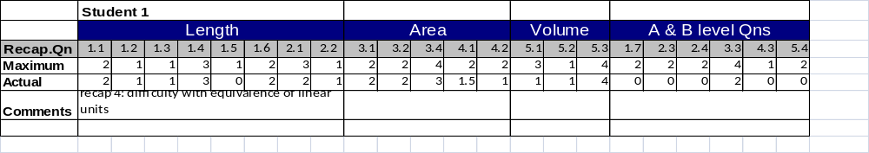
Table 3.1 – Spreadsheet for recording students’ performance on recap test questions.

First name | Surname | Predicted mark (out of 10 for each section)
 |  | Length MC 1,2,3,4,5 Sec B 1,2,3ab,4,5 | Area MC 6,7,8 Sec B 3cd 6,7,8 | Volume MC 9,10 Sec B  z9,10,11 | A & B Qns Sec B 12,13,14 | Confident/ Uncertain (within 10%) | Percentage | Grade | No A&B
Student | One | 7 | 6 | 8 | 2 | U | 60% | HM | 69%
Table 3.2 – Predictions completed by the teacher
First name | Surname | Actual mark
 |  | Length (15.5) | Area (11.5) | Volume (8) | A & B Qns (8) | Percentage | Grade | No A&B
Student | One | 11 | 6.5 | 7 | 1 | 59% | HM | 70%
Table 3.3– Actual marks extracted from corrected tests

Hypotheses and methods of testing them
Overall hypothesis: The provision of quality Formative Assessment information will assist teachers in making accurate predictions of students’ performance on a summative test.
Studies published since the data collection phase of this one have analysed the relationship between students’ test scores and teachers’ predictions of the same (Biuhagiar & Murphy, 2008; Smith, 2008). These studies have relied primarily on Pearson’s correlation coefficient between these quantities. This approach, while common (e.g. Coladarci, 1986; Hoge & Coladarci, 1989), was judged unsuitable for the study at hand. Even when Pearson’s correlation yields a high correlation, it does not explain the nature of the relationship. For example, if a teacher’s predictions were consistently 30 marks above the students’ test scores, then r would equal one, the strongest possible relationship. The researcher, in consultation with a statistician at the Statistical Consulting Centre of the University of Melbourne, has instead opted to count the incidence of “accurate” predictions, defined here as those falling within 10% of a student’s test mark. Spearman’s rank order correlation coefficient was also calculated to determine the relationship between the ranking of the students based on the teacher’s predicted scores and the test scores, respectively. Pearson’s r was quoted as an additional measure to facilitate comparison with other research.
While the study was initially designed with two teachers implementing the formative assessment instruments designed by the researcher and two others not doing so, it was never the intention for the latter two to be seen as a control group. Interviews with all participating teachers aimed to identify the greatest number of helpful sources of information employed by each of them when predicting students’ performances.
Hypothesis 2: teachers are most accurate in predicting the achievement of highly performing students and least accurate for low performing students (Coladarci, 1986).
The students were divided into three groups based on their test scores: “high”, “medium” and “low”. These represent the top 25%, the middle 50% and the lowest 25% of the scores. The accuracy of the teacher’s predictions was measured for each of these groups separately. While this method parallels the one used by Biuhagiar and Murphy (2008), the decision to employ it was taken prior to the publication of that paper. Subsequently, the researcher revisited his analysis to make reference to that study as it helped shed light on his own findings.
The interviews with teachers were also used to ascertain the teachers’ practices that made teachers more accurate when predicting the performance of one ability group rather than the others.
Hypothesis Three: teachers would find it easier to predict students’ performance on routine questions than those requiring problem-solving skills. This hypothesis was based on the researcher’s experience as well as a review of the research by Hoge and Coladarci (1989).
The same measures utilised to test the overall hypothesis were also employed after the A and B level questions were removed from the predicted and test scores. The teacher interviews were also used as an opportunity to ask teachers about the sources of their predictions of the students’ performance on these questions.

Methodology
This research has elements of experimental design as well as case study. Like an experiment it introduces an intervention, the recap sheets. However, it is not primarily a statistical study, where the effectiveness of the intervention is established in comparison with a control group. The experimental intervention is evaluated through consideration of the differences between the three teachers’ utilisation of formative assessment.
This research also borrows from the method known as a case study. It examines one specific issue in the context of a single school, that is, the sources of teachers’ assessments of student achievement in Measurement at Year Seven Level. It does so with a wider interest in mind. That is to say, the researcher views the case as indicative of teachers’ sources of assessment in other mathematical topics and at other year levels. The study also aims to see how the provision of a particular form of Formative Assessment can add to these sources of assessment. This is what Stake terms an instrumental case study, where “a particular case is examined mainly to provide insight into an issue or to redraw a generalization” (2000, p. 445).

Researcher’s perspective
In this study, the researcher is also a participant. The researcher’s initial interest was in integrating the formative and summative functions of assessment. This interest arose from the fact that assessment was taking up much of class time and his own preparation time. The idea of integrating both functions would achieve efficiencies, while helping guide the students’ learning. This concern with efficiency has led the researcher to devise an intervention, namely the recap sheets, which would not impinge on a teacher’s time in a dramatic way. No major reform of the participating teachers’ view of teaching and learning was attempted in this study. If we accept the typification of views of learning in (Biuhagiar & Murphy) as either a process of transmission of knowledge from the teacher to the student or as an organic process of growth that learners undergo as they construct knowledge, then the intervention in this study is of use to teachers who hold either of these views. Both types of teachers want to know that the student can express the same measurement in different units and does not confuse perimeter and area.

Conclusion
In summary, the main features of the experimental case study described in this document are:
- It concentrates on the sources of teacher assessments of student progress in a particular school setting and explores the extent to which the provision of formative assessment information can help them in making such assessments.
- It incorporates researcher-generated assessment sheets that can be administered by teachers with minimal impact on their time in the classroom and outside of it.
- It aims to test three hypotheses using a mixed method where quantitative data are supplemented by information provided by interviews with participating teachers.
- It places the researcher in the position of a participant, providing a sympathetic perspective on the data.

Presentation and Analysis of the Quantitative Data

Introduction
The analysis of the quantitative data collected from each class aims to establish the extent to which each teacher was able to make accurate predictions of his or her students’ performance. This chapter will analyse the data from the two participating teachers other than the researcher. Where relevant, data concerning the researcher’s class will be presented with the researcher’s comments. To highlight the fact that the researcher is presenting his own data, the text will be in italic typeface with a border around it and expressed in the first person.
As outlined in previous chapters, the study looks at each teacher’s predicted marks and compares them to the marks achieved by students on a test. A predicted mark is considered accurate if it fell within 10% of the test mark achieved by the student. The research attempts to answer three questions that correspond to the three hypotheses stated in Chapter 3:
- How accurate was the teacher in predicting the students’ performance? This question will be broken into two sub-questions:
  - With what accuracy did the teacher predict their rank order?
  - How often was she able to make an accurate prediction of their test score?
- How did the inclusion of A and B level questions affect the accuracy of the teacher’s predictions?
- How was the accuracy of the teacher’s predictions related to the students’ ability level?
When comparing predicted and test marks for an entire class, this study will use correlation coefficients. Spearman’s correlation will determine the strength of the relationship between the rank order of the marks, while Pearson’s correlation will be used as a measure of the relationship between the test marks. The latter is quoted here to facilitate comparison with other studies that have used Pearson’s correlation as the main measure. As discussed in Chapter 3, the researcher has chosen to rely on the count of accurate predictions as the ultimate measure of a teacher’s predictive capacity. It must be reaffirmed that the intention is not to accord unconditional status to the test mark, but to pose the question, “If the teacher(s) can predict the students’ test scores consistently and with accuracy, what purpose is served by the summative test? As will be seen, the number of discrepancies between predicted and actual test scores, although small, was sufficient to oblige the teacher to seek additional information to resolve any such discrepancies. This, in itself, justifies the use of both summative tests and the process of test score prediction.

Maria’s class
Maria provided data on 24 of the 25 students in her class. The data are presented in an order that will help answer each of the three questions listed above.

The accuracy of the teacher’s predictions
Table 4.4 below shows correlation coefficients that compare the marks predicted by Maria and the marks achieved by the students on the test. Spearman’s correlation compares the rank order of the scores. This rank order correlation has the value 0.869, indicating a very strong and positive correlation between the predicted ranking of a student’s score in the class and the ranking of her test score. Pearson’s r also shows a strong and positive relationship between the predictions and the test scores.

 |  |  | Test Mark
Spearman's rho | Predicted Mark | Correlation Coefficient | .869(**)
 |  | Sig. (2-tailed) | .000
Pearson’s r | Predicted Mark | Correlation Coefficient | .830(**)
 |  | Sig, (2-tailed) | .000
 |  | N | 24
** Correlation is significant at the 0.01 level (2-tailed).
Table 4.4 – Correlations between predicted and test marks (Maria’s class)
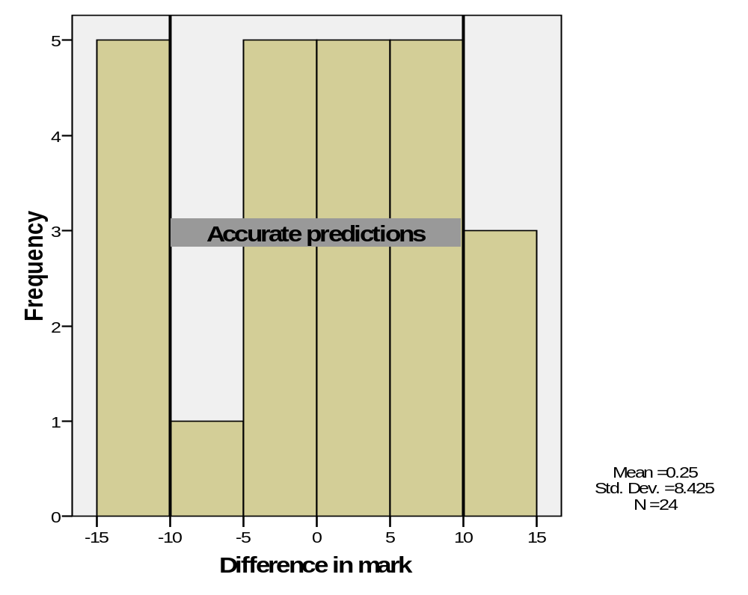
Figure 4.1- Histogram showing the frequency of percentage differences between predicted and test marks (Maria’s class)
Figure 4.1 helps us quantify the differences between the predicted and test marks. The distribution curve in the figure shows that the mean difference was close to zero. In fact it was 0.25. The median difference was exactly zero. This suggests that Maria’s predictions were evenly spread. Taking a 10% accuracy margin either way, the histogram shows that a total of eight students were outside of this margin. In other words, Maria was accurate in predicting the marks of 16 out of 24 of her students.
We are now in a position to answer the first analysis question, relating to the accuracy of Maria’s predictions of her students’ test marks.

Answering the first question
To answer the first of the analysis questions, we can say that Maria:
a. Predicted the rank order of her students in a way that correlated strongly with their test rank (ρ = .869);
b. Made an accurate prediction of the actual test scores of two-thirds of her students (16 out of 24)

The effect of excluding the A and B level questions
One of the researcher’s hypotheses was that teachers would find it more difficult to predict students’ performance on questions that involve a student’s problem-solving ability. The data allow us to exclude the A and B level questions so that we are left with scores relating to questions that are similar to the exercises covered in class.
Table 4.5 below shows the correlations calculated on the marks excluding the A and B level questions. It can be seen that the values of both correlations are lower than those calculated on the overall data. This does not support the researcher’s hypothesis. However, the correlations remain strong and positive.
 |  |  | Test Mark No A&B
Spearman's rho | Predicted Mark No A&B | Correlation Coefficient | .835(**)
 |  | Sig. (2-tailed) | .000
Pearson’s r | Predicted Mark No A&B | Correlation Coefficient | .818(**)
 |  | Sig, (2-tailed) | .000
 |  | N | 24
(**) Correlation is significant at the 0.01 level (2-tailed).
Table 4.5 – Correlations between predicted and test marks excluding A and B level questions (Maria’s class).
Figure 4.2 helps us quantify the differences between the predicted and test marks excluding the A and B level questions. As the bars of the histogram show, there were five students for whom the prediction fell outside of the 10% accuracy range. This was an improvement over the accuracy of predictions before the A and B level questions were excluded. Then, there were three more inaccurate predictions.
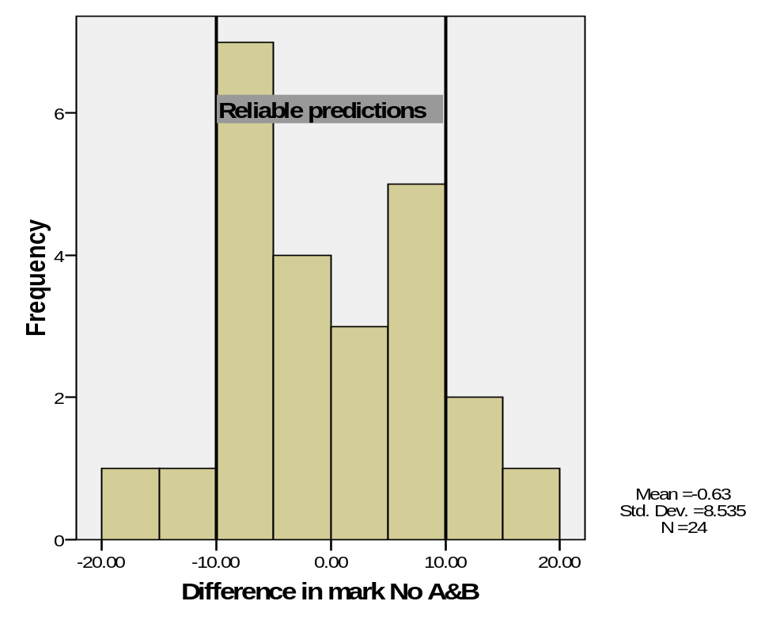
Figure 4.2 Histogram showing the frequency of percentage differences between predicted and test marks excluding A and B level questions (Maria’s class)
We are now in a position to answer the second analysis question, relating to the effect of the A and B level questions on the teacher’s ability to predict the students’ performances.

Answering the second question
Notwithstanding a small decrease in the value of the rank order correlations, the statistics indicate that Maria was able to make an accurate prediction for more students when the A and B level questions were excluded. 79% of the students (nineteen out of twenty four) achieved a mark within 10% of the prediction.

Grouping students according to ability
To answer the third question, namely the one on Maria’s ability to predict the performance of students of different levels, the students were divided into three ability groups:
- Low: Test marks between minimum (55%) and lower quartile (65.25%);
- Medium: Test marks between lower quartile (65.25%) and upper quartile (77.75%); and
- High: Test marks between upper quartile (77.75%) and maximum (84%)
Table 4.6 below shows that the low performing group was the one with the highest percentage of accurate predictions. In this group, 87% of the students (six out of seven) had an accurate prediction compared with 66.67% of the students in the high group (two thirds) and 55% of the medium group. The high group had the greatest mean difference – a 9% overestimation.
 |  |  |  | Predicted Mark | Test Mark | Percentage difference in mark*
Quartile ranking | high | 1 |  | 92 | 79 | 13
 |  | 2 |  | 88 | 79 | 9
 |  | 3 |  | 92 | 84 | 8
 |  | 4 |  | 84 | 80 | 4
 |  | 5 |  | 92 | 84 | 8
 |  | 6 |  | 90 | 78 | 12
 |  | Mean difference |  |  |  | 9.00
 |  | Total | N | 6 | 6 | 6
 | low | 1 |  | 60 | 59 | 1
 |  | 2 |  | 60 | 62 | -2
 |  | 3 |  | 63 | 65 | -2
 |  | 4 |  | 66 | 66 | 0
 |  | 5 |  | 50 | 62 | -12
 |  | 6 |  | 53 | 55 | -2
 |  | 7 |  | 53 | 57 | -4
 |  | Mean difference |  |  |  | -3.00
 |  | Total | N | 7 | 7 | 7
 | medium | 1 |  | 86 | 74 | 12
 |  | 2 |  | 61 | 67 | -6
 |  | 3 |  | 65 | 70 | -5
 |  | 4 |  | 82 | 73 | 9
 |  | 5 |  | 66 | 77 | -11
 |  | 6 |  | 72 | 72 | 0
 |  | 7 |  | 61 | 74 | -13
 |  | 8 |  | 77 | 76 | 1
 |  | 9 |  | 82 | 73 | 9
 |  | 10 |  | 61 | 73 | -12
 |  | 11 |  | 66 | 77 | -11
 |  | Mean difference |  |  |  | -2.45
 |  | Total | N | 11 | 11 | 11
 | Total | N |  | 24 | 24 | 24
* Students’ results for which the difference was greater than 10% are highlighted in grey.
Table 4.6 – Percentage differences between predicted and test marks in each ability group. Positive indicates overestimate (Maria’s class).
The next subsection answers the third analysis question.

Answering the third question
We can now answer the question concerning the relationship between the students’ ability level and the accuracy of Maria’s predictions. One of the researcher’s hypotheses was that teachers would be most accurate in predicting the performance on their highly performing students. We can say that, contrary to this hypothesis, Maria was least consistently accurate in predicting the marks of her high performing students.
The correlation coefficients for my class are displayed in Table 4.7 below. It can be seen that the correlation between the predicted and test marks were strong, positive and statistically significant at the 1% level. Unlike Maria’s class, the correlations in my own were higher when the A and B level questions were excluded. This suggests that the hypothesis reflected the researcher’s personal experience.
Figure 4.3 below shows the distribution of the differences between predicted and test marks. As can be seen from the figure, there are 17 students for whom the prediction fell inside the stipulated 10% margin (68% of the class). The distribution of the differences when the A and B level questions were excluded is depicted in Figure 4.4. This time, my predictions for 18 students were accurate (72% of the class).
While not indicating a strong effect, the data in my class are consistent with my hypothesis that teachers would be more accurate in predicting student performances in the absence of A and B level questions. All three measures indicated a very small improvement in my predictions when the A and B level questions were removed.

 | Spearman’s ρ | Pearson’s r
Test mark vs Predicted mark | 0.712** | 0.768**
Test mark vs Predicted mark (no A & B questions) | 0.734** | 0.820**
** Correlation is significant at the 0.01 level (2-tailed).
Table 4.7 – Correlations between predicted and test marks (Researcher’s class)
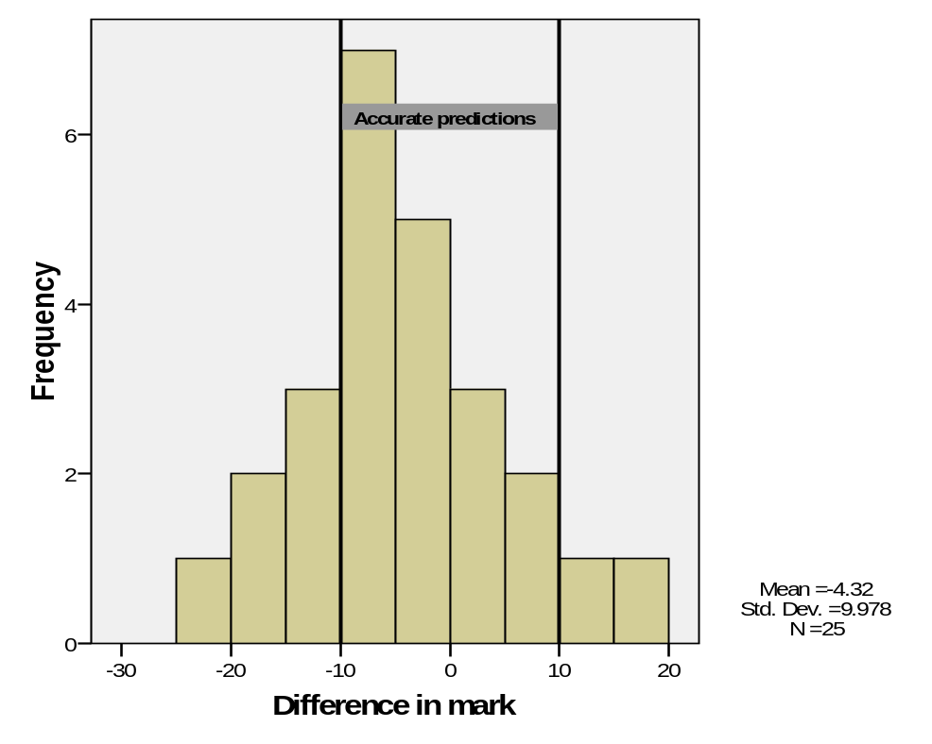
Figure 4.3 - Histogram showing the frequency of percentage differences between predicted and test marks (researcher’s class)
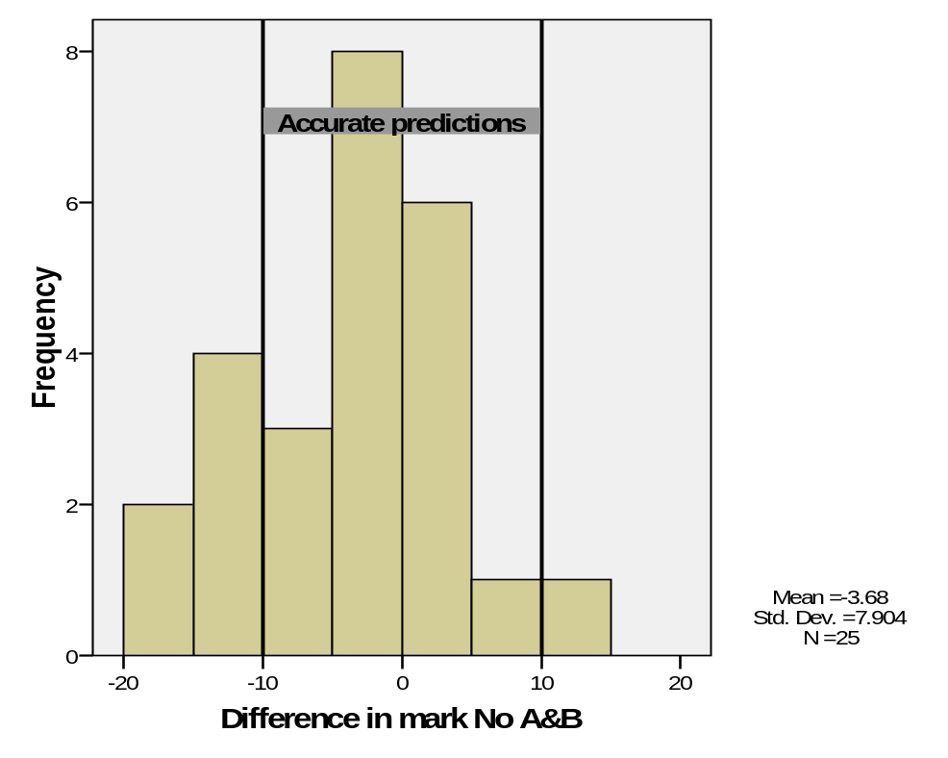
Figure 4.4 - Histogram showing the frequency of percentage differences between predicted and test marks excluding A and B level questions (researcher’s class)

Looking at the distribution of grades using the data collected from Maria’s and the researcher’s classes
It has already been stated that Maria’s ranking of her students was very similar to their test ranking. Figure 4.5 shows that the test marks were more narrowly distributed than the ones predicted by Maria. The effect of this distribution on the allocation of grades is shown in and Table 4.9.
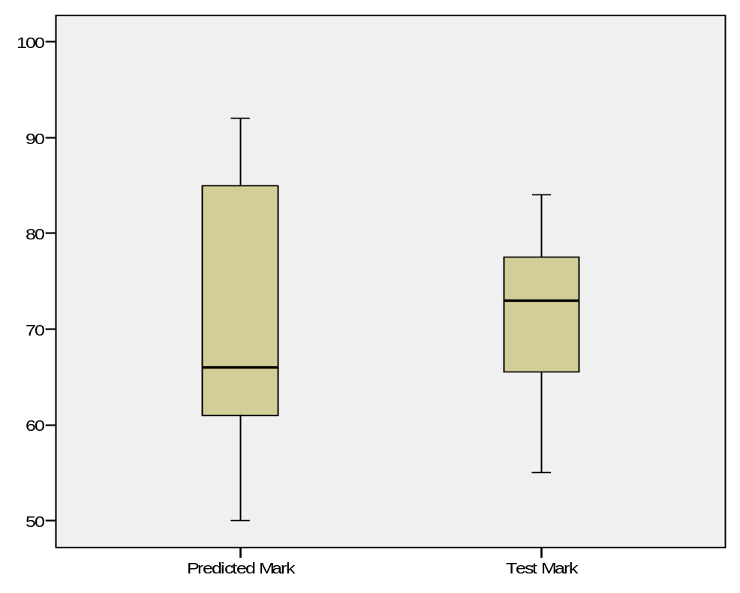
Figure 4.5 - Parallel boxplots: predicted and test marks

 |  | Predicted Grade |  | Test Grade
Grade |  | Frequency | Percent | Frequency | Percent
 | Very High | 4 | 16.7
 | High | 2 | 8.3
 | High Medium | 15 | 62.5 | 22 | 91.7
 | Medium | 3 | 12.5 | 2 | 8.3
 | Total | 24 | 100.0 | 24 | 100

Table 4.8 - Distribution of grades from predicted and test marks (old grading scheme)

 |  | Predicted Grade |  | Test Grade
Grade |  | Frequency | Percent | Frequency | Percent
 | Excellent | 0 | 0 | 0 | 0
 | Very High | 6 | 25 | 0 | 0
 | High | 4 | 17 | 9 | 38
 | Medium | 11 | 46 | 15 | 62
 | Low | 3 | 12 | 0 | 0
 | Non-Satisfactory | 0 | 0 | 0 | 0
 | Total | 24 | 100.0 | 24 | 100
Table 4.9 – Distribution of grades from predicted and test marks (new grading scheme)
The two tables above show the grades allocated to the students using both the grading scheme in use at the time that the data were collected and the one that has been introduced since. The two grading schemes are listed in Appendix A. Both tables show that, through her predictions, Maria was able to achieve what a test is usually designed to do, namely to discriminate between students so that they achieve a wide range of marks that in turn correspond to a wide range of grades. The highest and lowest grades are usually intended for a small percentage of students and the middle ones (Medium, High Medium) intended for the majority. In this case, the test marks have resulted in 91.7% of Maria’s students receiving a High Medium and the remainder a Medium.
Table 4.10 compares the students’ test marks to those predicted by me. It can be seen that I was most accurate in predicting the marks of the low group and least accurate in predicting the marks of the medium group. Yet, despite the accuracy of my predictions of the test marks of every student in the low group, every student in this category would have received a different grade depending on which marking scheme was used. On the other hand, only three out of 13 students in the medium group would have received a different grade.
Considering Student 1 in the low group and Student 11 in the medium group (both in bold) highlights the problem of mapping marks to grades. It can be seen that Student 1’s predicted and test grades are different despite the fact that the difference between her test and predicted marks was one mark only. In contrast, Student 11’s test and predicted grades are the same. This is despite the large difference between her predicted and test marks.

Quartile ranking | Student number |  | Predicted Mark | Test Mark | Difference in mark* | Predicted Grade** | Test Grade**
high | 1 |  | 83 | 91 | -8 | HM | VH
 | 2 |  | 92 | 94 | -2 | VH | VH
 | 3 |  | 71 | 88 | -17 | HM | H
 | 4 |  | 94 | 98 | -4 | VH | O
 | 5 |  | 73 | 87 | -14 | HM | H
 | 6 |  | 89 | 90 | -1 | H | VH
 | Mean difference |  |  |  | 6.59
 | Total | N | 6 | 6 | 6 | 6 | 6
low | 1 |  | 45 | 44 | 1 | M | LM
 | 2 |  | 58 | 59 | -1 | M | HM
 | 3 |  | 54 | 60 | -6 | M | HM
 | 4 |  | 63 | 55 | 8 | HM | M
 | 5 |  | 52 | 59 | -7 | M | HM
 | 6 |  | 43 | 47 | -4 | LM | M
 | Mean difference |  |  |  | 5.54
 | Total | N | 6 | 6 | 6 | 6 | 6
medium | 1 |  | 84 | 77 | 7 | HM | HM
 | 2 |  | 69 | 81 | -12 | HM | HM
 | 3 |  | 63 | 81 | -18 | HM | HM
 | 4 |  | 73 | 79 | -6 | HM | HM
 | 5 |  | 63 | 72 | -9 | HM | HM
 | 6 |  | 64 | 79 | -15 | HM | HM
 | 7 |  | 90 | 76 | 14 | VH | HM
 | 8 |  | 86 | 67 | 19 | H | HM
 | 9 |  | 86 | 83 | 3 | H | HM
 | 10 |  | 77 | 84 | -7 | HM | HM
 | 11 |  | 61 | 84 | -23 | HM | HM
 | 12 |  | 63 | 73 | -10 | HM | HM
 | 13 |  | 66 | 62 | 4 | HM | HM
 | Mean difference |  |  |  | 12.59
 | Total | N | 13 | 13 | 13 | 13 | 13
Total | N |  | 25 | 25 | 25 | 25 | 25
* Entries where the percentage difference exceeds 10% are highlighted in grey.
** Entries where the predicated and test scores would have resulted in a different grade have been highlighted in black.
Table 4.10 – Percentage differences between test and predicted marks in each ability group. Positive indicates overestimate (Researcher’s class).
The anomalies discussed in this section highlight the issues associated with mapping marks to grades. It is beyond the scope of this study to make more specific comments about this issue, except to problematise the process of grading.

Questions raised by analysis
This analysis of the quantitative data collected from Maria’s class raises the following questions:
- What made Maria overestimate the performance of her high-performing students?
- What made Maria more accurate in predicting the marks of her low-performing students?
An attempt will be made to answer these questions in the next chapter, where the researcher’s interview with Maria is discussed.

Lillian’s class
Data were collected on 22 out of 25 students in Lillian’s class. As was the case for Maria’s class, the data are presented in an order that will help answer each of the three questions listed at the beginning of the chapter.

The accuracy of the teacher’s predictions
Table 4.11 below shows correlation coefficients that compare the marks predicted by Lillian and the marks achieved by the students on the test. This correlation has the value 0.741, indicating a strong and positive correlation between the predicted ranking of a student’s mark in the class and the ranking of her test mark. Pearson’s r also shows a strong and positive relationship between the predictions and the test scores.
 |  |  | Test Mark
Spearman's rho | Predicted Mark | Correlation Coefficient | .741(**)
 |  | Sig. (2-tailed) | .000
Pearson’s r | Predicted Mark | Correlation Coefficient | .733(**)
 |  | Sig, (2-tailed) | .000
 |  | N | 22
** Correlation is significant at the 0.01 level (2-tailed).
Table 4.11 – Correlations between predicted and test marks (Lillian’s class)
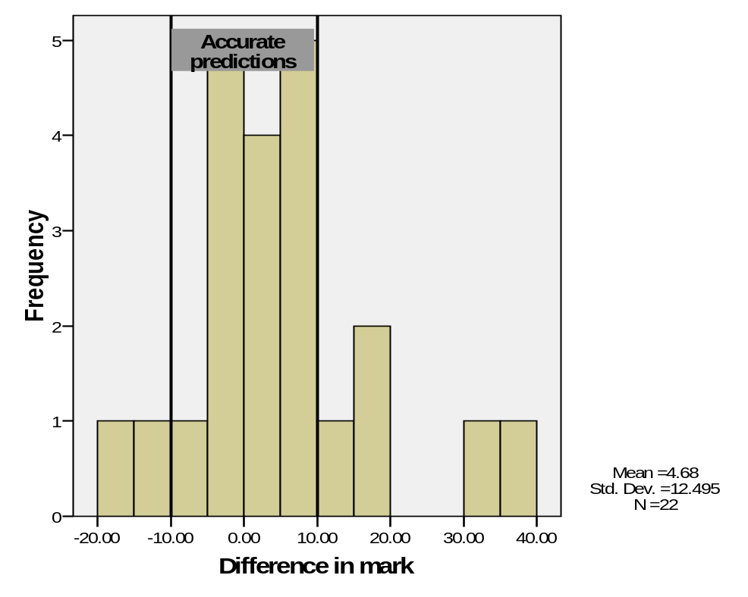
Figure 4.6 - Histogram showing the frequency of percentage differences between predicted and test marks (Lillian’s class)
As can be seen in Figure 4.6, seven students fell outside of the 10% accuracy margin specified in this study. This leaves 15 students (68%) inside the accuracy margin. The marks of two students were overestimated by 32 and 36 marks, respectively.

Answering the first question
To answer the first of the analysis questions, we can say that Lillian:
- Predicted the rank order of her students in a way that correlated quite strongly with their actual rank (ρ = 0.741);
- Made an accurate prediction of the marks of 68% of her students (15 out of 22 students).

The effect of excluding the A and B level questions
As can be seen from Table 4.12 below, both correlations have increased in size when and A and B level questions were excluded. This is in keeping with the researcher’s hypothesis as it indicates that Lillian was more successful in ranking her students and predicting their marks in the absence of questions that called on their problem-solving skills.
 |  |  | Test Mark No A&B
Spearman's rho | Predicted Mark No A&B | Correlation Coefficient | .784 (**)
 |  | Sig. (2-tailed) | .000
Pearson’s r | Predicted Mark No A&B | Correlation Coefficient | ..781 (**)
 |  | Sig, (2-tailed) | .000
 |  | N | 22
Table 4.12 – Correlations between predicted and test marks excluding A and B level questions (Lillian’s class).

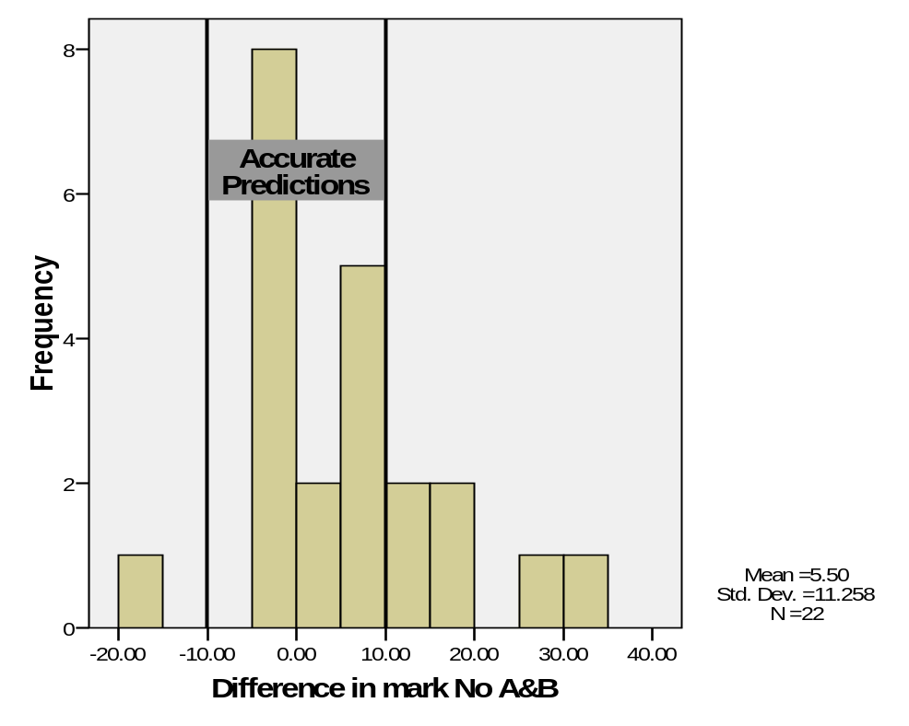
Figure 4.7 - Histogram showing the frequency of percentage differences between predicted and test marks excluding A and B level questions (Lillian’s class)
Figure 4.7 above helps us quantify the differences between the predicted and actual marks excluding the A and B level questions. As can be seen, the mean difference in marks was 5.5 marks, well within the reliability margin of 10%. Once again, seven students fell outside of the reliability margin specified in this study. Once again, there were two students whose test marks were more than 25 percentage points outside of Lillian’s prediction. Together, these measures help us answer the second analysis question.

Answering the second question
While the predicted and test ranks of the students showed a greater correlation, there was a slight increase in the mean difference between the predicted and test marks. The same number of students fell within the accuracy margin of ten percent as before the exclusion. In summary, Lillian’s ability to predict the performance of her students was not greatly affected by the presence of A and B level questions on the test.

Grouping students according to ability
To answer the third question, namely the one concerning Lillian’s ability to predict the performance of students of different levels, the students were divided into three ability groups:
- Low: Test marks between minimum (32%) and lower quartile (49.50%);
- Medium: Test marks between lower quartile (49.50%) and upper quartile (70.50%); and
- High: Test marks between upper quartile (70.50%) and maximum (94%)
Table 4.13 below shows that Lillian was clearly most accurate in predicting the marks of the low group. 100% of the students in that group received test marks that were within 10% of the predicted ones. 66.67% of the predictions for the medium group were accurate, while a mere 40% of the predictions for the high group were accurate.

Answering the third question
The answer to the third question is that Lillian’s ability to predict a student’s performance was related to the ability level of that student. The statistics that were explored suggest that she was best able to predict the marks of the students in the low ability group. This is consistent with the findings for Maria’s and the researcher’s classes and, like them, contradicts the researcher’s hypothesis that teachers were most accurate in predicting the performance of the high ability students. The next chapter considers the teachers’ statements regarding students of different abilities and provides a possible explanation for this phenomenon.
 |  |  |  | Predicted Mark | Actual Mark | Difference in mark
Quartile Ranking | high | 1 |  | 93 | 78 | 15.00
 |  | 2 |  | 90 | 94 | -4.00
 |  | 3 |  | 86 | 75 | 11.00
 |  | 4 |  | 71 | 76 | -5.00
 |  | 5 |  | 77 | 94 | -17.00
 |  | Mean difference |  |  |  | 0
 |  | Total | N | 5 | 5 | 5
 | low | 1 |  | 48 | 39 | 9.00
 |  | 2 |  | 53 | 45 | 8.00
 |  | 3 |  | 28 | 32 | -4.00
 |  | 4 |  | 40 | 41 | -1.00
 |  | 5 |  | 55 | 48 | 7.00
 |  | Mean difference |  |  |  | 4
 |  | Total | N | 5 | 5 | 5
 | medium | 1 |  | 85 | 53 | 32.00
 |  | 2 |  | 57 | 50 | 7.00
 |  | 3 |  | 88 | 52 | 36.00
 |  | 4 |  | 58 | 57 | 1.00
 |  | 5 |  | 55 | 51 | 4.00
 |  | 6 |  | 57 | 58 | -1.00
 |  | 7 |  | 65 | 64 | 1.00
 |  | 8 |  | 52 | 64 | -12.00
 |  | 9 |  | 85 | 69 | 16.00
 |  | 10 |  | 58 | 57 | 1.00
 |  | 11 |  | 49 | 56 | -7.00
 |  | 12 |  | 66 | 60 | 6.00
 |  | Mean difference |  |  |  | 7
 |  | Total | N | 12 | 12 | 12
 | Total | N |  | 22 | 22 | 22
Table 4.13– Percentage differences between predicted and marks in each ability group. Positive indicates overestimate (Lillian’s class).

Questions raised by analysis
This analysis of the quantitative data collected from Lillian’s class raises a question that the qualitative analysis will attempt to answer:
- Why was Lillian most accurate in predicting the performance of her low ability students?
It is hoped that the interviews with both Maria and Lillian will provide clear answers to this question. This would assist in explaining the inconsistency of these findings with those suggested by other research, namely Biuhagiar and Murphy (2008) and Coladarci (1986).

Conclusion
This chapter has analysed the data collected from the three participating classes and answered three analysis questions for each of them. The next chapter presents the participating teachers’ reflections on individual students and seeks to answer questions raised by this analysis. A comparison of the key measures collected from all three classes is deferred to the Conclusions chapter. This allows the thesis’ author to draw on the quantitative data presented in this chapter as well as the qualitative data presented in the next one.

Qualitative Analysis

Interview with Maria

Background to the interview
Maria is a part-time teacher at Avila College. She has worked in several schools, mainly in the Catholic sector. At the time of the study, her total experience spanned eighteen years, the last five of which were at Avila College.
Maria taught the Measurement unit to her Year Seven class and used the recap sheets provided by the researcher.
In analysing the interview with Maria, the researcher was looking to answer three questions, the first two of which were raised by the quantitative analysis:
- What made Maria overestimate the performance of her high-performing students?
- What made Maria more accurate in predicting the marks of her low-performing students?
- Did the use of Formative Assessment instruments such as the recap sheets add to Maria's ability to make accurate predictions of her students' performance?
The researcher asked Maria about four of her students: Sandra, Lucy, Rita and Joanna. Sandra and Lucy were students for whom Maria had made accurate predictions, falling within ten percentage points of the marks they achieved on the test. Rita and Joanna were students for whom the difference between Maria’s prediction and the test mark was more than 10%. The last two students in Table 5.14 were nominated by Maria for discussion.

Student | Predicted mark | Test mark | Predicted mark excluding A & B level questions | Test mark excluding A & B level questions
Sandra | 60% | 62% | 69% | 73%
Lucy | 66% | 66% | 77% | 76%
Rita | 61% | 73% | 70% | 81%
Joanna | 92% | 79% | 97% | 90%
Jenny | 82% | 73% | 89% | 73%
Ruken | 50% | 62% | 57% | 76%
Table 5.14 – Students discussed in interview with Maria
The sections below present Maria’s statements about these six students, together with the researcher’s analysis of the same.

Discussion of Maria’s accurate predictions
As can be seen in Table 5.14 above, Sandra and Lucy’s test marks were very close to their teacher's prediction. Maria classified Sandra as below class average. She had weak number skills and did not know her tables. Maria said, “When we did the recapping, she showed me that she understood some of the new concepts but still the same problems kept cropping up.”
Concerning Lucy, Maria stated, “her results have been improving through the year and I had the idea ..., from the recapping again, that she was keeping up with what we were doing.” She added that Lucy “can never seem to be able to handle the A and B type questions”. This was borne out by Lucy's result on the test as her mark improved from 66% to 76% once the A and B level questions were excluded. When the test result was pointed out to Maria, she remarked “She was up with everybody else in her understanding.”
As can be seen from the above discussion, Maria made her predictions for each of Sandra and Lucy by referring to an assessment of the student's level in comparison with the rest of the class (“up there with everyone”, “below class average”) and to the student’s performance on the recap sheets.

Discussion of Maria’s inaccurate predictions
In describing Rita, Maria used the terms “unpredictable”, “messy”, and “misinterprets the question”. In summary, Rita was a student whose performance would have been difficult to predict. When asked about the sources of her predictions for Rita, Maria referred to a worksheet that covered area, on which Rita had achieved nineteen out of twenty. The possible reasons that led Maria to underestimate Rita's performance were:
- Rita was doing her homework throughout this unit when this had not been the case earlier in the year; and
- Rita had a history of not finishing tests.
According to Maria, Joanna was one of the two “bright students in the class”. Her overall test mark of 79% was “her lowest mark all year.” It was clear from her statements that Maria thought highly of Joanna's mathematical ability. “She usually can do most questions, even the most difficult ones. Her problem-solving ability is really high.”
The researcher pointed out that Joanna had lost marks on Area (8.5 out of 11.5) and done poorly in the A and B level questions (2.5 out of 8). Maria restated her surprise at the performance, “usually she gets the A and B almost done, completely.” Then, referring to an open-ended B level question, she added “we've done these to death in class.” Maria also referred to the second B level question (see question 13 in appendix C) and exclaimed “I was pretty amazed 'cause she usually does well on those sorts of questions.” Maria also pointed out that Joanna had made mistakes to do with converting units, “yet her decimal work is really good.” Such unexpected results are inevitable, even when continuous assessment has been applied. Students’ performance is not so consistent that a successful application of a skill on an exercise is guaranteed to be replicated on the test.
When discussing her predictions for both Rita and Joanna, Maria did not refer to their performance on the recap sheets. The only, indirect, reference to the sheets was her surprise that Joanna could not complete an open-ended question that was similar to ones seen in class. The researcher assumed that this referred to the similarity of that question to ones on the recap sheets. A look at the notes that Maria had kept on the recapping reveals that Joanna's performance on the similar questions, Recap 2 questions 3 and 4 (see appendix B), would have also led Maria to predict a successful attempt. On these questions, Joanna had achieved two marks out of two and one mark out of two, respectively.
In summary, Maria seems to have relied mostly on Rita and Joanna’s performances in previous topics, taught earlier in the year. In a study of UK Mathematics teachers, Morgan and Watson (2002) report this tendency to rely on impressions of a student built up over time among their participants. They discuss the case of Sandra, a twelve year old student who had succeeded in creating a good impression in the teacher’s mind about her arithmetic skills. She did this with her answers to questions completed at home with her mother’s help. The teacher had a negative impression of Sandra’s problem-solving skills, because she had often asked for help. The teacher was reluctant to change either of these impressions even when presented with observations from a researcher who sat in the back of his classroom. The researcher saw Sandra often using her fingers to work out answers to simple subtractions. She also observed that Sandra could indeed devise alternative strategies to solve problems. The excessive help that she sought from her teacher tended to relate to her poor number skills. The authors summarise Sandra’s case with the following words:
‘what she had done before’ included creating an impression in [the teacher’s] mind; therefore, his judgments were relative to the picture already formed. In this case, the teacher had already changed his mind once about Sandra because of a dramatic difference between a low entry test result and her confident demeanor in the classroom. He was slow to change his opinion again, even in the light of accumulating evidence (Morgan & Watson, p. 92, p. 92).
A similar account, this time of a Year Seven boy in a Melbourne school, is found in Clarke (1989). Bernie, the boy in the study, had made a deliberate choice to improve his behaviour in class and went on to separate himself from less studious friends. He worked better in class and completed homework. His results began to improve, but the impression of his peers and teacher only changed after months of this improvement.

Discussion of students nominated by Maria
The researcher asked Maria to nominate other students to discuss. She nominated Jenny and Ruken.
Jenny's name had come up when discussing Joanna as one of the “bright students in the class”. Maria made a comparison of the two while discussing Joanna's results, and stated that Jenny was the kind of student who “doesn't check her work”. Furthermore, Maria stated that she expected Jenny “would keep to the habit that she's been keeping all year ... so I took that into consideration when I was predicting marks.”
When she nominated to speak about Jenny specifically, she asked the researcher about her marks. The researcher stated that the predicted mark was 82% and the test mark was 73%. It should be noted that this falls within the 10% margin. Maria argued that the last two questions on the test, questions 13 (B level) and 14 (A level) were “really hard” and “a little bit beyond them, even the brighter kids”.
Maria assessed Ruken's skills as “really, really poor”. Maria had predicted that Ruken would achieve an overall mark of 50%, rising to 57% when the A and B level questions are taken out. Ruken's test score was 62%. Her performance excluding the A and B level questions was a surprisingly high 76%. Maria said that she had based her prediction on what Ruken “usually does” and stated that “she's obviously been working on her number skills.” Maria also noted that Ruken had been attending numeracy support classes with a colleague. That colleague had reported that Ruken was “really keen to do really well”. She also observed that Ruken had followed her advice on how to set out her work.
As was the case with the students discussed in the previous section, it is clear that Maria’s unsuccessful prediction of Ruken’s test result was built on the latter’s historical performances rather than more recent ones. This points to the importance of increasing the incidence of teachers observing student performances on mathematical tasks. The use of recap sheets is one way of achieving this. The practice of predicting student results may also serve to bring changes in a student’s performance to the teacher’s attention.
Looking at Table 5.15, it can be seen that all four students whom Maria expected to achieve a score of 90% or higher had underperformed by an average of 10.25%. All four improved once the A and B level questions were excluded, with the improvement averaging 6.5% per student. This would tend to support Maria's contention that the A and B level questions were generally too difficult, even for the better performing students. This explanation, however, does not seem to be sufficient, as the exclusion of A and B level questions did not result in a change to the fact that all 6 students in the high category performed below Maria’s predictions.
Student number | Predicted mark | Test mark | Difference (Predicted – Test mark) * | Test mark no A& B | Difference (Test no A&B – Test mark)**
Student 8 | 92 | 79 | 13 | 90 | 11
Student 13 | 92 | 84 | 8 | 89 | 5
Student 18 | 92 | 84 | 8 | 91 | 7
Student 25 | 90 | 78 | 12 | 81 | 3
 |  | Average difference | 10.25 |  | 6.5
* Positive implies overestimate
** Positive implies improvement without A & B level questions
Table 5.15 – Marks achieved by students who were predicted to achieve 90% or better (Maria’s class).
In an attempt to further investigate the basis of Maria’s predictions, the next section presents Maria’s answers to a variety of questions put to her by the researcher.

Further discussion of predictions
The researcher then presented Maria with the correlation between her predictions and the students' test marks (r = 0.83) and the correlation excluding the A and B level questions (r = 0.82). The researcher remarked on the fact that his expectation was for the coefficient to be higher when the A and B questions were excluded and that this result contradicted that expectation. In what the researcher understood as a reference to the recap sheets, Maria stated, “I think it is because we have been doing the A and B level questions all the way through [in the recap sheets] and we have an idea how the students will perform on these questions.”
The following is a recounting of some general questions that were put to Maria, and her answers to those questions.
Question: Looking at this, instead of giving marks, if you were actually to predict grades, do you think by the end of the unit you ... could have graded the students without giving them this test?
Answer: Not unless I’ve had them for at least 6 months ... If I had their (sic) knowledge of their number skills, like I have now, I’d say yes, I think I could have.
Question: If you were to have to grade [the students] at the end of the unit, what sorts of things do you think can be helpful to help you do that?
Answer: I think the recapping was really good. I think because that told me what I needed to go over with the girls straight away ... they actually read [the teacher’s comments] on them. ... I said you go and fix those … do those hints that I’ve told you, you’ve got 5 minutes, and I heard them discussing, you know, what have I done wrong here and that sort of thing. Very few of the girls left the units off and that’s a major problem normally in measurement is they forget to put the units in. Because we kept pushing that all the way through, because they could actually see it on something they’ve done, they actually made sure that they were correct. So I think the recapping was really important. What else, doing worksheets, taking them up. Like the recap was short and quick but going and doing a worksheet on something and taking it up, you can see their strengths and their weaknesses. Especially if the worksheet like that Maths Attack one which had easy questions then complicated ones, you could see which students could actually tackle those.
From this discussion, it can be seen that Maria was confident in her ability to allocate grades to her students in the absence of a summative test, provided this would not be asked of her early in the year. This confidence is supported by the discussion of the grade distribution among Maria’s students (see section 4.2.7). She also pointed to the importance of the recap sheets as a teaching and learning tool. This can be seen from statements such as: “that told me what I needed to go over” and “because they could actually see it on something they’ve done, they actually made sure that they were correct”.

Answering the questions
Given Maria's own statements regarding the sources of her successful predictions, the following answers are suggested to the questions posed at the beginning of this section:
- Maria’s high performing students found the A and B level questions difficult. However, no satisfactory explanation was found to account for Maria’s tendency to overestimate the performance of the students in the high category. This is because the overestimation continued to apply even when the A and B level questions were excluded.
- Of the students who were discussed in this interview, Sandra was the only one who fell in the “low” category. Lucy was in the low end of the “medium” category, achieving a score of 66%, the lowest score in that category. In both cases, Maria referred to the recap sheets and to their comparative performance with regards to other students. This method seems to be a hallmark of Maria’s accurate predictions.
- The recap sheets did indeed add to Maria's ability to make successful predictions about her students' performance. This is despite her considerable experience as a teacher and her use of other assessment instruments.
The underperformance of those students whom Maria had expected to achieve a score of 90% or higher made me look at my students who fell in the same category. I had expected three students to achieve 90% or higher. Of these, Margaret and Lara achieved a higher score than I had predicted while Ruby performed substantially below my prediction. My predictions for all three students are shown in Table 5.16 below.Table 5.17 shows my prediction on each section of the test.
Both Margaret and Lara had excellent skills. Margaret had attended weekend coaching classes which had extended her skills beyond what would be expected at Year Seven level. This was why I predicted that she would achieve full marks on everything except the A and B level questions. I thought that Lara might find the mixed area questions slightly more difficult and predicted 9 out of 10 for that section. Both of the students performed well and managed a full mark on the A and B level questions. Their overall marks were close to my predictions, though they lost a few marks in areas different from those I had expected.
Ruby's arithmetic skills were reasonable, though not as strong as those of the first two. She was making mistakes on the recap sheets. However, she was able to correct those mistakes when the sheets were returned in class. Ruby was also able to offer alternative solutions to some of the open-ended questions on the recap sheets. This led me to believe that she would manage to overcome her difficulties by the end of the unit. My prediction would have been more accurate had I lent more weight to Ruby's performance on the recap sheets rather than to my expectation of improvements on her part.
Another factor may have affected her performance on the test. As the class' homeroom teacher, I was aware of the fact that Ruby had been distressed by events taking place in her family in the week leading up to the test. This may have prevented her from revising the content and consolidating her skills.
Knowledge of factors such as domestic difficulties may be useful in explaining a discrepancy between predicted and test performances in retrospect. However, it is not easy to quantify such circumstances when attempting to predict a student’s performance on a test. It is possible to argue, in such cases, that a test is a less appropriate measure of student capability than continual assessment taken throughout the unit.

Student | Predicted mark | Test mark | Predicted mark excluding A & B level questions | Test mark excluding A & B level questions
Margaret | 94% | 98% | 100% | 97%
Lara | 92% | 94% | 97% | 93%
Ruby | 90% | 76% | 90% | 81%
Table 5.16 – Best performing students in researcher's class

Student | Length (10) | Area (10) | Volume (10) | A & B level (10)
Margaret | 10 | 10 | 10 | 7
Lara | 10 | 9 | 10 | 7
Ruby | 9 | 9 | 9 | 9
Table 5.17 – Predicted marks for each section of the test

Interview with Lillian

Background to the interview
Lillian is a Mathematics and Science teacher. At the time that the study was conducted, she was in her fourth year of teaching, all of which had been at Avila College. She was the homeroom teacher of the Year Seven class that is discussed in this document and also taught Mathematics and Science to that class.
Lillian taught the measurement topic to her class without using the recap sheets or any other instruments designed by the researcher. At the end of the teaching sequence, she predicted the performance of her students in the same way as Maria and the researcher.
In analysing the interview with Lillian, the researcher was looking to answer the following questions, the last of which was raised by the quantitative analysis in the preceding chapter:
- In the absence of structured formative assessment instruments, what did Lillian rely on when making predictions about her students’ performance?
- Why was Lillian most accurate in predicting the performance of her low ability students?
Student | Predicted mark | Test mark | Predicted mark excluding A & B level questions | Test mark excluding A & B level questions
Mirna | 40% | 41% | 49% | 51%
Esther | 58% | 57% | 67% | 64%
Kylie | 88% | 52% | 97% | 64%
Rachelle | 77% | 94% | 83% | 99%
Karina | 28% | 32% | 34% | 39%
Maya | 52% | 64% | 59% | 64%
Table 5.18 - Students discussed in interview with Lillian
Before discussing particular students, Lillian stated: “I based my predictions on my gut and what I know about the kids in class”. She later added that she had taken “mental notes” on some of the students during the instruction sequence.
What follows is a report on the discussion of the students listed in Table 5.18.

Discussion of Lillian’s accurate predictions
Mirna was the first student to be discussed of those whose test mark was within 10% of the prediction. The predicted marks for Mirna were 40% and 49% excluding the A and B level questions. Her test marks were 41% and 51%, respectively. Lillian described Mirna as a “very weak” student who had “a lot of trouble focusing”. Mirna could do well if she were following a similar example but struggled with “putting everything together in a test.” When predicting Mirna’s performance, Lillian relied on the following expectations:
- Mirna would have some knowledge of length from Primary School;
- She would struggle with questions on the area of shapes other than rectangles; and
- She would gain an above average mark on volume, because she only needed to find the volume of a rectangular prism.
The other student in this category is Esther. As can be seen in Table 5.14, the predicted marks, 58% and 67% excluding A and B level questions, were very close to the test ones, 57% and 64% excluding A and B level questions. Here, Lillian’s position as homeroom teacher meant that she was aware of the fact that Esther had “personal issues”. Esther had been “in and out of class”, presumably to see the school counsellors. Esther had also mentioned to her teacher that she could not see composite shapes. As a result, Lillian “worked more one on one with her on a more regular basis so ..., for this topic, [Lillian] knew whereabouts she was”.
In making her predictions, Lillian mentioned the following points:
- She knew that Esther would attempt the A and B level questions but would not do well on them, because “she’s not that strong on the high level thinking”.
- She expected that Esther would be helped by the fact that she was neat and careful. Lillian used words like ‘she’s incredibly neat’, ‘very careful’ and ‘rarely makes errors’. That would have helped her gain maximum marks for showing her steps.
Lillian ended her comments about Esther with the following statement: “that’s one of the reasons why I was close, because I spent more time with her than other students.”
In discussing both of these students, Lillian showed an intimate knowledge of their understanding of the topic. The reason for this seems to be the fact that she had spent time working closely with each of them. Concerning Esther, Lillian mentioned working “one on one with [Esther] on a more regular basis”. Concerning Mirna, she mentioned “I’ll call on her a number of times when I’m at the board just to make sure ... I’ve got [her] on board.”

Discussion of Lillian’s inaccurate predictions
Lillian described Kylie, whom the researcher had brought up pointing to the discrepancy between the predicted and test marks. Kylie was predicted to achieve 88% and achieved a score of 52%. Lillian said that she considered Kylie “quite bright but … does not push herself”. She had achieved inconsistent marks on tests. Lillian considered measurement a topic that Kylie “would excel at” as “the mathematics [was] straight forward” and required following well-rehearsed steps.
Another student whom the researcher asked about was Rachelle. Rachelle was predicted to achieve 77% and achieved a score of 94%. Lillian said that Rachelle was “very good at doing what she was told. … She reminds me of a Kumon sort of student where … she’s not so good at problem-solving, but she’s very good at the rote stuff”. Rachelle had made mistakes in previous tests and Lillian expected her to do the same. It is important to note that Rachelle was on the border of an “Outstanding” grade and Lillian would have had to judge whether she would be prepared to award that grade. Instead, Lillian stated, “I just know that she’s not quite up there even though she came as 94%.”
In discussing both of the students that the researcher brought up and for whom her prediction had fallen outside of the 10% margin, Lillian used her memory of the students’ historical performances in mathematics: how they had performed on previous tests and a description she had built up of their mathematical behaviour (e.g. does not push herself, a Kumon sort of student). It should be remembered that this reliance on past performance was a characteristic of Maria’s inaccurate predictions.

Discussion of students nominated by Lillian
The researcher then asked Lillian to nominate students she wished to discuss. The first student she nominated was Karina. Lillian predicted that Karina would achieve 28% and 34% when the A and B level questions were excluded. Karina’s test marks fell close to these predictions and were 32% and 39%, respectively. Lillian said that Karina had had difficulties with converting units and she had spent time working with her on this skill. Karina had been away when area was taught and Lillian allowed her to bring a sheet of notes to the test but she expected that “working off the sheet would not have helped that much anyway.”
Lillian then brought up Maya and asked the researcher “how did I go with [Maya]”? The researcher, referring to Maya’s overall percentage mark, answered, “You predicted 52, she got 64”. Lillian spoke about Maya as a student who had gotten progressively “better” over the course of the year. She stated that Maya “considered herself very weak at Maths”. Lillian’s own impression was that she possessed “excellent problem-solving skills but didn’t “believe any in herself.” Lillian summed up her view of Maya by saying, “I find her really difficult to predict, ‘cause she can be brilliant .... But she can be really weak and get lost.”

Further discussion of predictions
A very brief discussion followed between the researcher and Lillian. The main points made by Lillian were:
- She found the performance of Year Seven students more difficult to predict than that of year eights for the following reasons:
  - “I suppose in Year Seven, when they’re all over the place, you know it’s not just the maths that we’re focusing on.” This was understood by the researcher as a reference to the difficulty that year seven students can have in adapting to their new environment.
  - “I was quite out [with the high performing students], because they’re up and down, all over the place, because they haven’t quite got the hang of what high-school Maths is about, even though the skills are there.” This was understood by the researcher as a reference to the students’ difficulties in dealing with the rigours of the curriculum and, especially, learning to set out their work in the required manner.
We are now in a position to answer the questions posed at the beginning of this section.

Answering the questions
To the first question, that regarding the sources of Lillian’s predictions, the answer seems to be two-fold, a knowledge of a student’s previous performances and time spent working with the student during the instruction sequence. Here it may be relevant to note Lillian’s expressed difficulty in predicting the performance of Year Seven students whom she described as inconsistent (“up and down, all over the place”). It may be that the provision of formative assessment instruments such as the recap sheets would have helped her in this regard.
The answer to the second question, the one relating to Lillian’s greater knowledge of the low ability students, seems to be the fact that she had spent more time working one-on-one with the students that had displayed the most difficulties.

Lillian’s knowledge of her lowest performing students made me examine my own performance with the “low” category of students in my class.
Looking at Table 5.19 below, it is possible to see that all of my predictions for the six students in the low quartile rank were within 10% of their test mark. Student 21, Imogen, was an above-average student. Her number skills were reasonable and she usually worked well in class. In the case of this topic, she had been absent when we learned Area and Volume. In fact, she sat the test later than all but one student in the class so she could have enough time to study the work. I predicted that she would still pass, but that she would struggle with more difficult questions. My predictions for Imogen are shown in Table 5.20. Since she had been absent when the recap sheets were given on Area and Volume, I simply predicted “just above average” for Area and “just below average” for Volume. Given this “guess work”, I marked my predictions with a “U” for “unconfident”. Of course, the volume questions outside of the A and B level section were reasonably simple. I should have predicted a higher mark for that section. This suggests that reliance on judgement, when this judgement is not backed up by specific observations, can be misleading.

Student Number | Predicted Mark | Test Mark
Student 2 | 45 | 44
Student 8 | 58 | 59
Student 13 | 54 | 60
Student 19 | 63 | 55
Student 21 | 52 | 59
Student 23 | 43 | 47
Table 5.19 – Predicted and test marks of students in the low category (researcher’s class)
 | Length | Area | Volume | A & B level
Predictions (out of 10) | 7 | 6 | 4 | 2
Test (out of 10) | 8 | 6 | 8 | 0
Table 5.20 – Imogen’s scores on each section of the test.

Conclusion
This chapter has looked at the reflections of all three participating teachers. Some remarks can be made to summarise the analysis of these reflections:
- Reliance on a student’s past performances was a common source of inaccurate predictions of that student’s test result;
- Continuous observations of a student’s work was generally a source of accurate predictions; and
- Teachers were most accurate in their predictions of the low category of students due to the fact that they had a more intimate knowledge of their strengths and weaknesses. Care for the less academic students is a hallmark of Avila College and this intimate knowledge on the part of teachers of the “low” category of students is a manifestation of this characteristic of the school’s culture.

Conclusions

The study revisited
This study implemented the intervention of the recap sheets. These were a formative assessment tool designed to be used to provide feedback to students and teachers about the students’ understanding of the Measurement topic (although the basic idea and structure could be applied to any topic). These recap sheets were employed by two of the three teachers in the study. At the end of the topic, the teachers were asked to predict their students’ marks on a summative test. These predictions, and the corresponding test marks, were collected and analysed by the researcher. The aim of the analysis was to identify practices that fulfil the goals of formative assessment while still leading to accurate summative reporting on students’ achievement in Mathematics.

Accuracy of teacher predictions
Table 6.21 shows the key statistics that allow us to summarise all that has been discussed in the previous chapters about the accuracy of teacher predictions. While all three had a high percentage of accurate predictions, Maria’s figures stand out for the small difference between her predictions and the marks achieved by the students on the test. None of her students’ test results was any more than 13 marks over or under her predicted mark.
Looking at the last row of the table shows that Lillian had overestimated her students’ test performance by an average of 4.68 marks, while the researcher had underestimated by an average of 4.32 marks.
 | Maria | Lillian | Researcher
Rank correlation | .869(**) | .741(**) | 0.712(**)
Percentage of accurate predictions | 67% | 68% | 68%
Range of differences between predicted and test marks | -13 to +13  Range = 26 | -17 to 36  Range = 53 | -23 to +19  Range = 42
Mean difference between predicted and test marks | 0.25 | 4.68 | -4.32
** Correlation is significant at the 0.01 level (2-tailed).
Table 6.21 – Comparisons of prediction accuracy among the three teachers in the study
Lillian mentioned in the interview that her students had lost marks because they had not set out their solutions in the way that she had stressed during the instruction sequence. This could be a possible explanation for her tendency to overestimate their test scores.
The researcher was surprised by how well the Year Seven students performed on the test given his experiences with teaching the same content to Year Eight students. It is possible to speculate that the use of the recap sheets supported the learning of the students. Below is the first of several boxes in this chapter that are aimed at reviewing the role of the recap sheets. These boxes appear in this chapter wherever it is relevant to expand on the role of the recap sheets as highlighted by the two teachers who used them: Maria and the researcher.
Role of recap sheets as an instructional tool: Both Maria and the researcher observed that fewer students than usual left out measurement units from their answers. Maria stated clearly in her interview that this was due to the fact that the students were receiving constant teacher feedback about this through the recap sheets. The researcher also believes that there were fewer instances of students confusing length and area when choosing their formulas. The nature of the questions on the recap sheets, which highlighted the relationship and difference between the two concepts, may provide an explanation for this.

Observations regarding Maria’s experience
It has already been pointed out that Maria had ranked the students in her predictions in a way that was similar to the test ranking, while distributing their grades in a way that discriminated more finely than the test was capable of doing. Combined with the accuracy of her predictions of the students’ test scores, this suggests that a teacher of Maria’s experience may well be able to report on student performance with more discernment using his or her own informal assessment than by relying solely on a summative test.
Role of recap sheets as a tool for formative assessment: Maria referred to the recap sheets when discussing her accurate predictions. She also made the point that the recap sheets were a quick and useful means of providing her with the necessary feedback about her students’ progress: “I think the recapping was really good. I think because that told me what I needed to go over with the girls straight away.”

Students’ ability level as a factor in predicting their performance
When the students’ test marks were divided into three categories (low, medium and high), the analysis showed that all three teachers were most successful in predicting the test performance of the students in low group. This runs contrary to one of the researcher’s original hypotheses and can be seen as one surprise that this study has thrown up. Earlier research had suggested that teachers were most accurate in predicting the achievement of highly performing students and least accurate for low performing students (Biuhagiar & Murphy, 2008; Coladarci, 1986). These studies had found that the more advanced students volunteered more answers and generally accounted for most of the student talk during lessons, thereby providing teachers with more information about the students’ understanding of the content.
The interviews with both Maria and Lillian included several references to them spending more time with their weaker students and asking more questions of them than the others. The same applied in the researcher’s class. This is perhaps indicative of the culture of the school in which this research was conducted. While the teachers interviewed by Biuhagiar and Murphy admitted focusing on the students most likely to pass high stakes examinations, Avila College enjoys a reputation as a school that cares for and improves the performance of the less able students.

The presence of questions requiring higher order thinking as a factor in predicting students’ performance
The study investigated the effect of the inclusion on the test of questions requiring higher order thinking. It had been hypothesised that teachers would find it easier to predict students’ performance on routine questions than those requiring problem-solving skills. This hypothesis was based on the researcher’s experience as well as a review of the research by Hoge and Coladarci (1989).
When the problem-solving questions were excluded, the results did not show a consistent pattern of improvement in the accuracy of teacher predictions as had been hypothesised. It must be noted that in the analysis, both the predicted and test marks were calculated using the same weighting for each section of the test. Therefore, the unexpected result was not a consequence of errors of calculation introduced by the exclusion of the A and B level questions. The researcher was unable to find a satisfactory explanation.
Role of recap sheets as a tool for the formative assessment of higher-order thinking: Maria expressed the view that the presence of open-ended questions on the recap sheets had provided her with the opportunity to ascertain her students’ ability to solve problems requiring higher order thinking.

Other factors affecting teachers’ predictions of students’ performance
When discussing inaccurate predictions, both interviewed teachers summarised their view of a student’s general ability with words such as “bright”, “good at the rote stuff”, “messy” or “not so good at problem-solving”. Both referred to the prior history of the student’s performances to justify these descriptions. When speaking about two of the students for whom she had made an inaccurate prediction, Maria made observations that could explain their better than-expected-performance. One of these students had been doing her homework throughout that unit, something she had not done historically. The other student had been attending numeracy support classes and improving her number skills. While Maria was aware of those facts, she ignored them when making her predictions. Reflecting on their results served to highlight those factors and one can assume that, should such favourable observations continue, Maria would lend more weight to them in forming her expectations of their future performance. In other words, when the teacher is given an opportunity to reflect on informal assessments and observations made about a student, these become part of the student’s performance history and the teacher’s view of the student’s capabilities is adjusted accordingly.
Role of recap sheets in bringing changes in a student’s performance level to the teacher’s attention: Recap sheets, being a form of informal assessment, can be administered with minimal impact on the teacher’s class’ time, and can provide teachers with frequent opportunities to challenge the picture that they have built up of a student. It is suggested that this be done in conjunction with the exercise of predicting students’ performances prior to administering further assessments. This practice has the potential to draw changes in a student’s performance to the teacher’s attention.
In the analysis of the researcher’s class, Ruby was discussed as a student who had performed significantly below the teacher’s expectation. As mentioned in the previous chapter, Ruby had begun experiencing difficult circumstances at home in the last few days of the instruction sequence. Despite being aware of the circumstances, the researcher ignored them when making his predictions. In such circumstances, relying on continuous informal assessments administered throughout the unit would be preferable to relying exclusively on an end-of-unit test taken at a time of distress.
Role of recap sheets as a continuous source of assessment information: Recap sheets provide a source of continuous assessment which can be used in lieu of an end of unit test when the teacher is aware that a student’s circumstances at the time of the test are likely to misrepresent his or her ability.

Problems with the use of grades as a means of reporting student performance
In the analysis of Maria’s class, we saw that, while she ranked her students in a way that was similar to the test, Maria was able to distribute the grades with more sensitivity than the test. The analysis showed the same more sensitive distribution using two different grading schemes: the one used at the time that the data were collected and one adopted more recently.
Another remark that was made in the analysis, this time in relation to the researcher’s class, was that students with a single mark’s difference in their score could be granted different grades, while students with a large difference in their marks could receive the same grade. Any table used to map scores to grades will suffer from at least one of two problems:
- Reducing the number of grades increases the number of students who fall within the same range and hence decreases the capacity of the grading scheme to distinguish between students;
- Increasing the number of grades increases the possibility that students with similar scores receive different grades. Given that there is an intrinsic uncertainty associated with every measurement, including test performance, grading schemes that are based solely on test marks will inevitably run the risk of misrepresenting the performance of many students.

Recommendations
The following recommendations can be made from this study:
- Teachers should develop formative assessment instruments that possess the properties of what this study has called “recap sheets”, namely brevity and the inclusion of questions that diagnose common misconceptions and link two or more concepts within the topic’s content domain.
- Teachers should administer these assessments as often as is practicable, perhaps on a weekly basis.
- Teachers should use these assessments to provide feedback to students, concentrating on a few mistakes each time and providing the students with enough time to act on the feedback. In some cases, the feedback could take the form of asking the student to find alternative solutions to previously completed tasks or suggesting extension activities.
- Teachers should be allowed the option of including in any report on a student’s progress reference to the student’s performance on these continuous assessment instruments. This should be done especially when a student’s circumstances at the time of a summative test are likely to affect his or her performance.
- Teachers should engage in the practice of predicting their students’ performance on future assessments so as to allow their students to demonstrate an unexpected change in their performance level and to draw to the teacher’s attention any discrepancies between the messages of formative and summative assessments.
- Teachers in a school should discuss the purpose and mechanism of allocating grades. This study has shown that the practice of grading can misrepresent a student’s performance.

Answering the study’s essential question
This study started with the question: “how can formative assessment assist teachers in predicting the students' level of achievement in Mathematics?” A major concern in the study design was to find a way of implementing formative assessment with minimal impact on the teacher’s time. The researcher looked to identify ways in which formative assessment instruments could be used to guide the teacher’s evaluation of a student’s performance so that they could be used to supplement and, in some cases, replace summative assessment instruments.
The researcher’s answer to the essential question is that the use of continuous formative assessment instruments can help teachers make accurate judgements of the performance of most of their students. This study has found that summative assessment remains necessary, as teachers needed to seek extra information on the performance of a small, but significant, number of students. It is possible that this last requirement is redundant when the teacher has extensive experience. Further study is required to clarify the role of the teacher’s experience.

Finally, assessment is a practice that serves many functions of which one is often overlooked: the social function. Summative assessment, through marks and grades, provides public recognition of effort and, some would argue, ability. Can informal assessment ever have the same social impact? It is suggested that a change in classroom culture could have profound impact on student motivation and learning. The researcher proposes the analogy of the use of “personal best” performances in sport. Students can gradually acquire skills, charted and certified by the teacher, and the recognition that comes from the number of skills acquired and certified in this way may be able to replace the one that comes from marks written in red pen on the front page of a summative test.

Appendix A: Grading schemes employed at Avila College
Grading scheme used at the time the data were collected:
Percentage mark | Grade
0 – 29 | Not Yet Evident
30 – 36 | Low
37 – 44 | Low Medium
45 – 58 | Medium
59 – 84 | High Medium
85 – 89 | High
90 – 94 | Very High
95 – 100 | Outstanding

Grading scheme currently used at Avila College:
Percentage mark | Grade
0 – 39 | Not Satisfactory
40 – 54 | Low
55 – 74 | Medium
75 – 84 | High
85 – 94 | Very High
95 – 100 | Excellent

Appendix B: Recap sheets
Sources: (Sullivan & Lilburn, 2004) and (Stambulic et al., 2006)
Recap 1: Units of length
Question 1: Name the units which would be the most suitable for measuring the following.
- The height of a plane above the ground
- The length of a bed

Question 2: Give two examples of something that would be best measured in metres

Question 3: Measure the following as accurately as you can to the nearest millimetre.

Question 4: Complete the following metric conversions.
- 7 cm = mm
- 3 km = m
- 56 000 mm = m

Question 5: John says to Martha: “The sum of our heights is 321.5 cm”. How tall might each of them be?

Question 6: The trunk of a tree has been cut up to make firewood. If there are 18 logs, all measuring 57 cm in length, find the original height of the tree in metres.

Question 7: Elizabeth measured a line to be 12 cm.
- What could the actual length be?
- If she had written the answer as 12.0 cm, would that have made a difference to your answer in (a)?
Recap 2: Perimeter
Question 1: Find the perimeter of the shape below and give your answer in centimetres. (The dots are one centimetre apart)
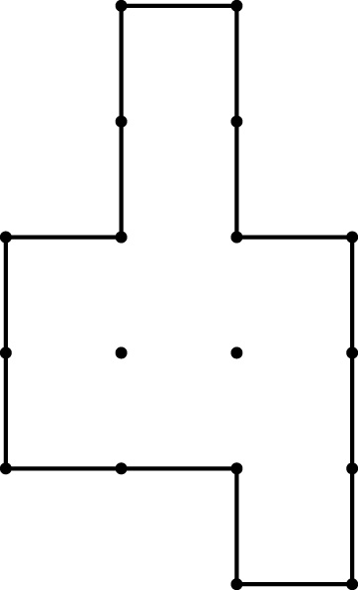 | 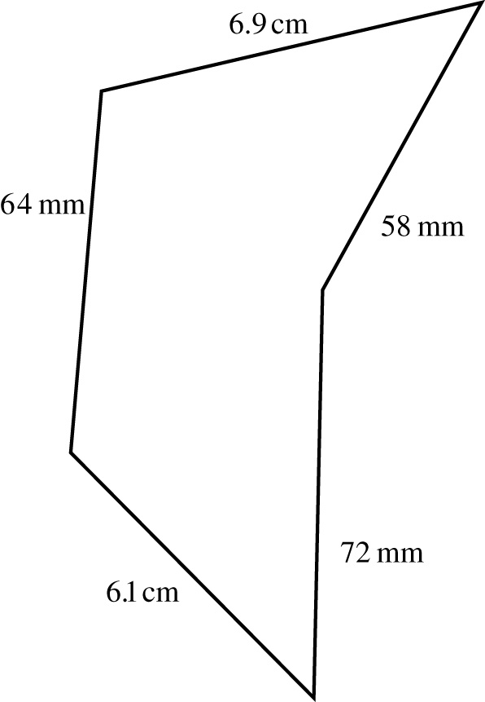

Question 2: Find the perimeter of a rectangle with length 4.3 m and width 5.2 m.

Question 3: You have 100 metres of fence for a garden. What might your garden look like? (The sections of the fence should be straight but the garden does not have to be a rectangle)

Question 4: It takes one metre of ribbon to tie up a package. Assume that the bow needs 30 cm. What might the dimensions (length, width, height) of the box be?


Recap 3: Area of rectangles

Question 1: Find the area of the following shapes in which each square has an area of 1 cm².  (a)  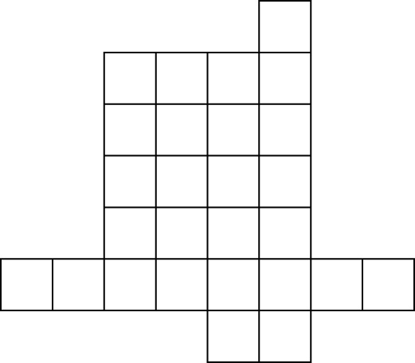 | (b)  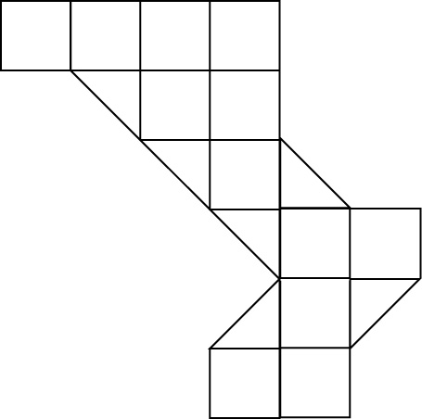
Question 2: Find the area of the following rectangles by using the formula A = l × w. Check the units in each question.  (a)  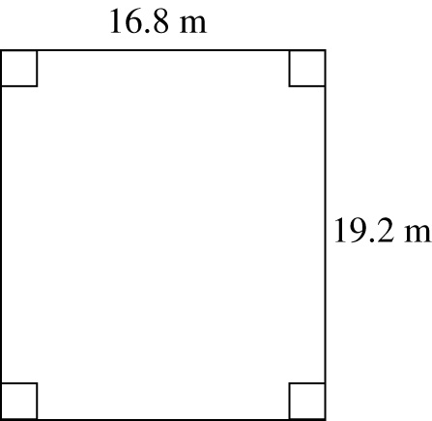 | (b)  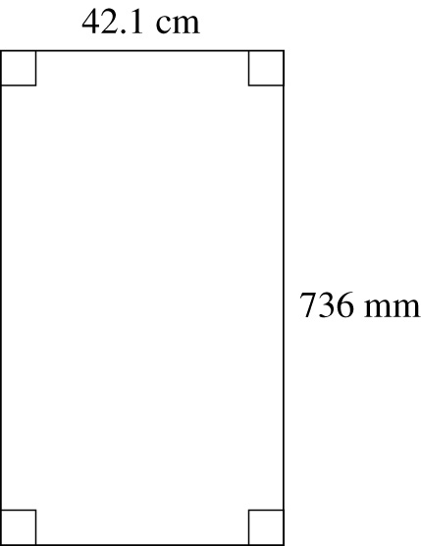
Question 4: Complete the following metric conversions.
(a) 3 cm = m (b) 5 m² = cm²
(c) 8.4 km² = m² (d) 2.4 cm² = m²

Question 3: A rectangle has an area of 36 cm².
Suggest possible dimensions? (write at least 3 possibilities)
Which of your answers would give the rectangle the largest perimeter?
Can you think of an answer that would make the rectangle a square?
Recap 4: Area of triangles & composite shapes
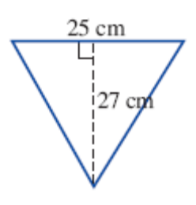Question 1: Find the area of the following triangles by using the appropriate formulas.  (a)  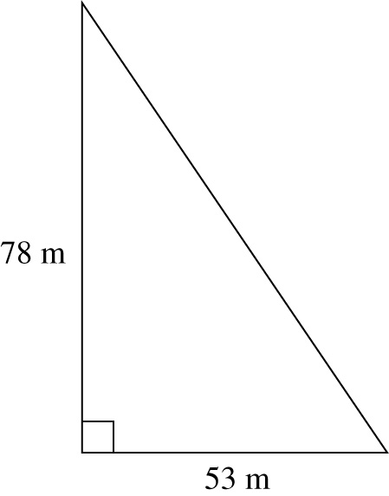 | (b)

Question 2: For the shape below, calculate: (i) the perimeter and (ii) the area.
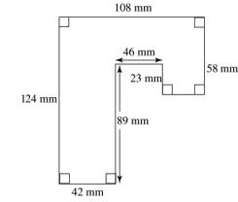

Question 3: Ask three unit conversion questions with answer 650 cm.

Recap 5: Volume and Capacity
Find the volume of the following.
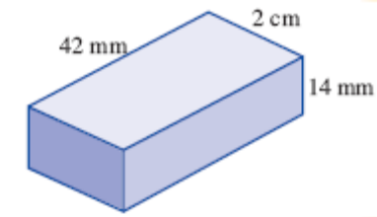  (a)  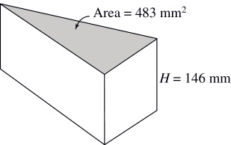 | (b)

Question 2: Arrange the following in order from smallest to largest.
4.82 L, 482 000 mL, 0.048 L, 482 mL, 48.2 L

Question 3: Complete the following unit conversions
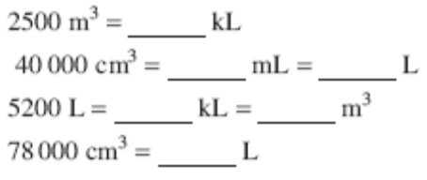

Question 4: A container holds 100 teaspoons of water. What might the container look like? (1 teaspoon holds 5 ml)
Appendix C: Summative Test
Measurement Test Name: ___________________________
Name: ___________________________

Section A Multiple Choice

The reading indicated by the arrow in the figure below is:

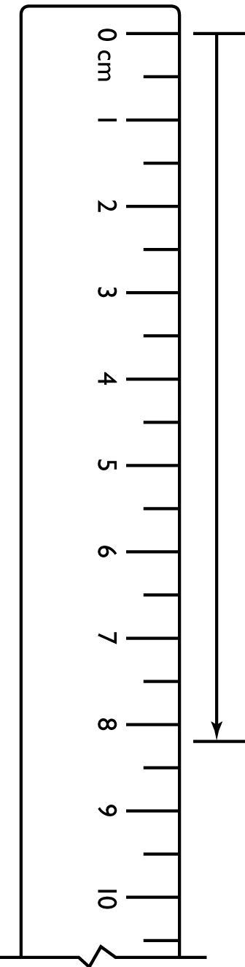
A 1.8 cm
B 2.8 cm
C 3.2 cm
D 8 cm
E 8.2 cm

6 km is equal to:

A 6 m
B 60 m
C 600 m
D 6000 m
E 60 000 m

142 cm is equal to:

A 1.42 m
B 0.0142 m
C 0.142 m
D 0.00142 m
E 14.2 m

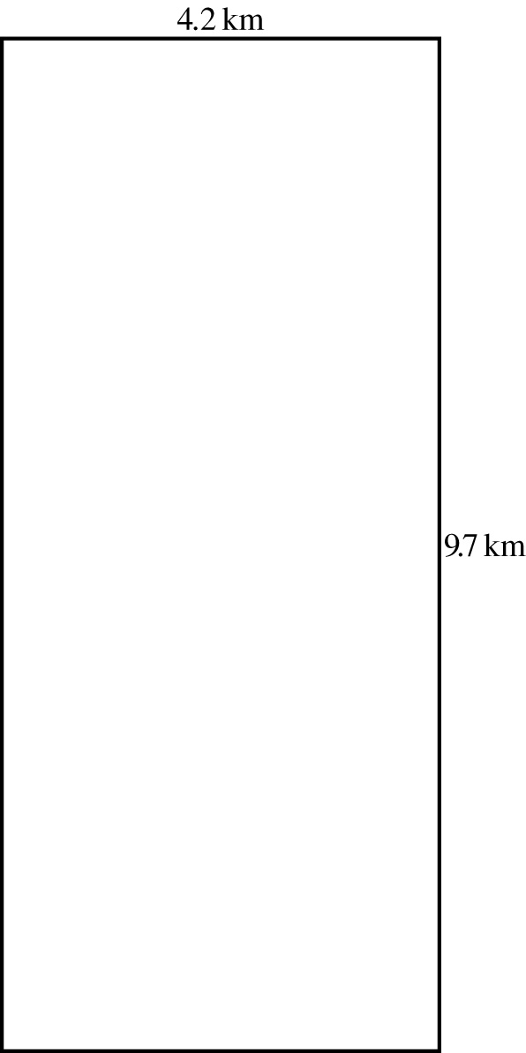

The perimeter of the shape above is:

A 11 km
B 27.8 km
C 13.9 km
D 36.9 km
E 40.74 km

The perimeter of the shape below is:

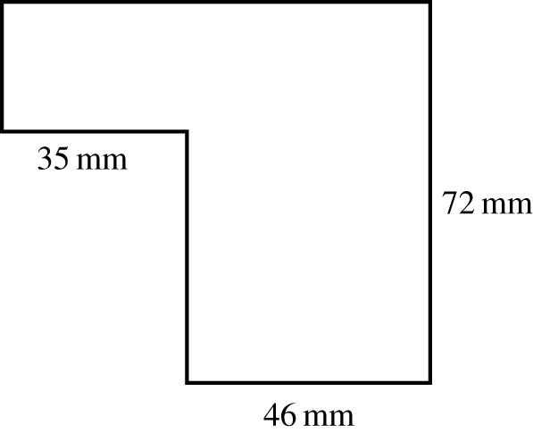

A 153 mm
B 225 mm
C 306 mm
D 1530 mm
E 3060 mm

6 | The most appropriate unit to measure the area of a tennis court is:  A mm²  B cm²  C m  D ha  E km
7 | The area of the figure below (which is drawn on centimetre grid paper) is:  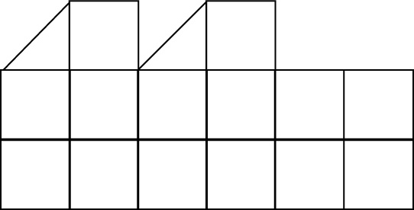  A 12 cm²  B 15 cm²  C 16 cm²  D 18 cm²  E 20 cm²
8 | The area of the rectangle shown below is:  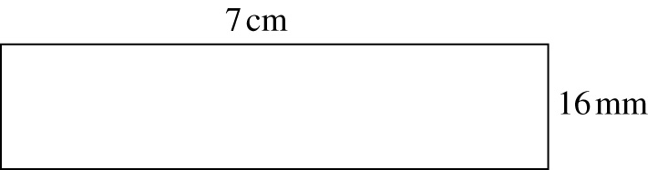  A 11.2 mm²  B 23 mm²  C 112 cm²  D 23 cm²  E 11.2 cm²
9 | The volume of a shoebox with length  15 cm, width 6 cm and height 4 cm is:  A 25 cm³  B 36 cm³  C 94 cm³  D 120 cm³  E 360 cm³
10 | What is 360 L equal to?  A 0.036 mL  B 36 mL  C 360 mL  D 360 000 mL  E 360 000 000 mL

Measurement Test Name: ___________________________

Section B Short/Extended answer
 | State the units which would be most appropriate to measure the following (mm, cm, m, or km). More than one answer is possible.  - the distance between Melbourne and Adelaide  - the width of a netball court  - the width of a text book  - the length of your fingernail |  | 4
 | Measure each of the following to the nearest centimetre..  (a)  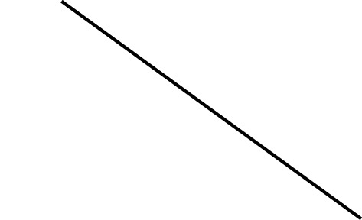  (b)  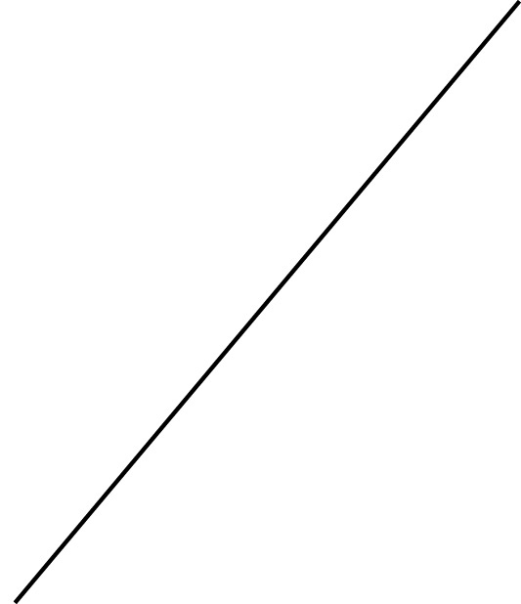 |  | 2
 | Complete each of the following metric conversions.  (a) 8 cm = mm  (b) 19 cm = km  (c) 14 mm² = cm²  - 2.8 km² = m² |  | 3
 | An athlete in training ran the following distances in a week: 4.8 km, 3.09 km, 5200 m, 4.5 km. Find the total distance run in kilometres. |  | 2
 | An equilateral triangle has a side length of  4.8 m. Find its perimeter. |  | 1 ½
6 | Find the area of the triangle shown below.  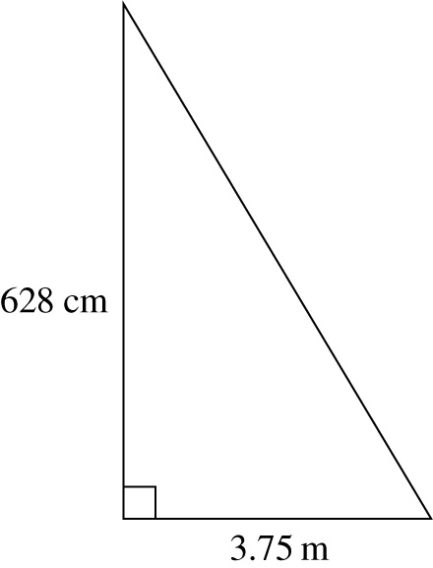 |  | 1 ½
7 | Find the area of the following shape.  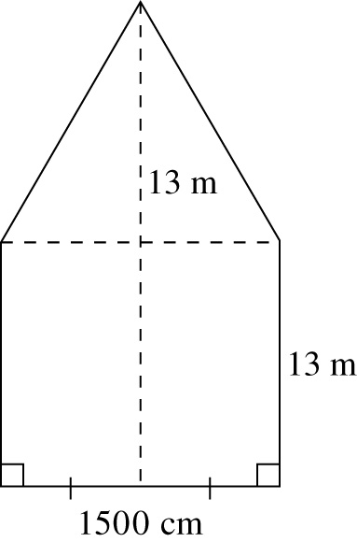 |  | 2
8 | Angela is carpeting her L-shaped lounge/dining room as shown below.  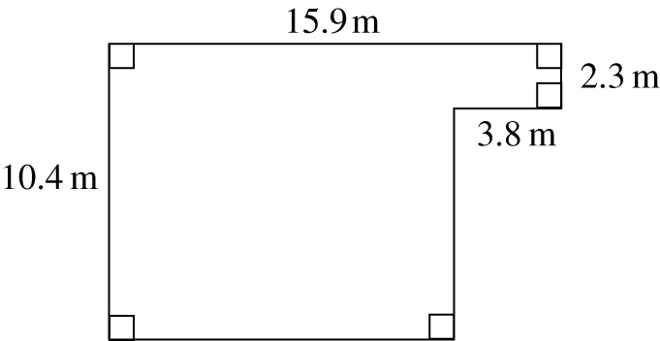  - Find the area that Angela needs to carpet.  - If the carpet costs $185 per square metre, how much will the new carpet cost? |  | 3
9 | Find the volume (in cm³) of the following solid shape. Assume each cube has a volume of 1 cm³.  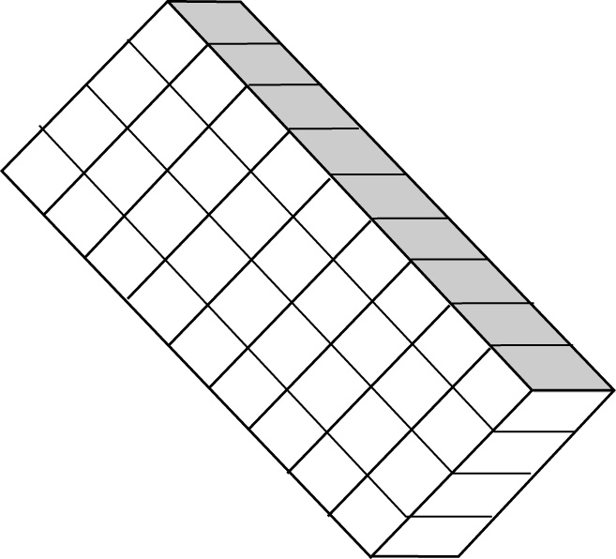 |  | 2
10 | Calculate the volume of the following prism.  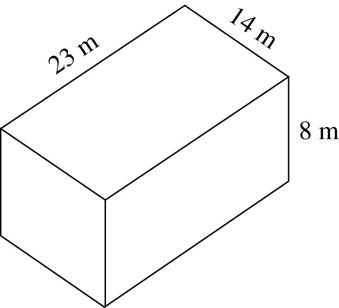 |  | 2
11 | Convert the following to the units shown in brackets.  - 4700 mL (L)  - 0.418 L (mL) |  | 2
12 | A rectangular classroom has a perimeter of 20 m.  List two possible answers for the dimensions of the classroom. |  | 2B
13 | Find the area of the figure below.  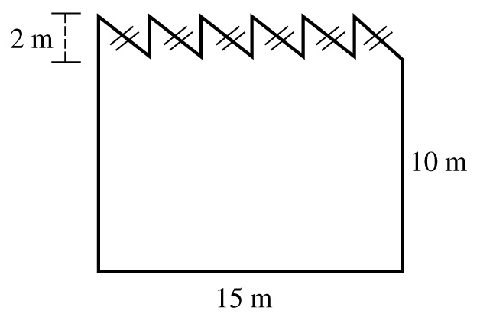 |  | 3B
14 | The figure below shows a home swimming pool.  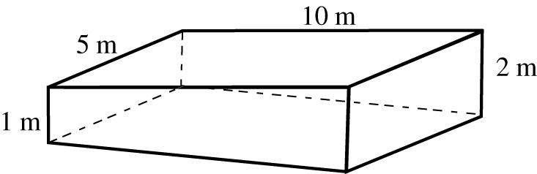  Find the capacity of the pool in litres (assume that the water level is to the very top of the pool) |  | 3A

Section A: ______ /10

Section B: ______ / 33

Total : _______ / 43 = _______ %
References

